MECHANICS II

Remember to photocopy 4 pages onto one sheet by going A3→A4 AND back to back on the photocopier

Student name: ________________________________

This booklet contains every higher and ordinary level question that has appeared on an exam paper on this topic from 2002–2023
Worked solutions to Ordinary Level Maths questions can be found at the end of the booklet.
Fully worked solutions to all higher level past papers can be found on the homepage of thephysicsteacher.ie

Screencasts of all topics plus a wide range of other resources via this link

You can find this document plus all other booklets on the homepage of thephysicsteacher.ie
Last updated: 04/08/2024
Noel Cunningham
Contents
The science of learning quiz: Part 9 3
1: ENERGY AND POWER 5
Something to think about 5
We eat the sun 5
What is energy? 6
Student Notes 7
Work 7
Energy 8
Work-energy principle 8
Different forms of energy 8
The principle of conservation of energy 9
Power 15
The kilowatt-hour 17
Percentage efficiency 18
The solar constant 19
SLOP 20
2: DENSITY AND PRESSURE 21
Something to think about 21
Student Notes 22
Density 22
Pressure 24
Upthrust 26
Archimedes’ principle 26
The law of flotation 27
Pressure in a gas: Boyle’s Law 28
VERIFICATION OF BOYLE’S LAW 29
SLOP 37
The science of learning quiz: Part 10 39
3: GRAVITY 41
Something to think about 41
Is gravity real - or does the Earth just suck? 42
Student Notes 43
Newton’s law of gravitation 43
Gravity and weight 45
Background reading 47
SLOP 50
The science of learning quiz: Part 11 52
4: MOMENT OF A FORCE 54
Student notes 54
A couple 55
Moment of a couple: Torque 55
Two laws of equilibrium 57
INVESTIGATION OF THE LAWS OF EQUILIBRIUM FOR A SET OF CO-PLANAR FORCES 60
SLOP 66
The science of learning quiz: Part 12 67
MECHANICS II EXAM QUESTIONS 2002 – 2023 69
Work, energy and power: Ordinary level 69
Questions involving momentum: Ordinary level 74
Work, energy and power: Higher level 76
Pressure and density: Ordinary level 79
Gravity: Ordinary level 79
Gravity: Higher level 82
Moment of a force: Ordinary level 83
SOLUTIONS TO ORDINARY LEVEL EXAM QUESTIONS 2002 – 2023 84

Apologies for being part of the most selfish generation in the history of mankind. Despite knowing full well the damage our obsession with material wealth was and is having on the planet, we made the very deliberate decision to ignore that information and just get on with life as if everything was all going to be fine.

Noel Cunningham

"Life is like a party where guests try to ignore a concealed sniper who takes them out one by one." Alain de Botton

You got 4 minutes to live. On the plus side, the clock resets every time you take a breath. Don't take this for granted.

The science of learning quiz: Part 9

- You’re about to begin your study for the evening. Only one of the following options will lead to a successful outcome – which one is it?
- The intention and desire to learn
- ‘Interrogating’ the material as you study it
- Learning in a way that matches your own learning style
- The time you spend studying

Wanting to learn is of no relevance whatsoever (if it was, we wouldn’t keep forgetting our passwords).
Learning styles is a myth (in the sense that you don’t learn better one way over another).
We know that time is of no significance if it’s not spent effectively.
Interrogating the material as you study is all that matters – see answer to question on elaborative interrogation.

- You have given yourself two hours to prepare for an upcoming test which is at the end of the week. Assume that you understand the concepts and now you just need to be able to remember all of it.Which of the following four options is the most effective (assume a half hour of study each night)?

Mon | Tues | Wed | Thurs
Read | Read | Read | Read
Read | Read | Read | Test yourself
Read | Read | Test yourself | Test yourself
Read | Test yourself | Test yourself | Test yourself

This option involves the maximum amount of retrieval:
Mon | Tues | Wed | Thurs
Read | Test yourself | Test yourself | Test yourself
Paper from The Journal of Experimental Psychology: Repeated Testing Produces Superior Transfer of Learning Relative to Repeated Studying
- Testing yourself serves two very important functions. What is the obvious one?
It identifies what you do and do not know.

- What is the other equally important function?
You are retrieving information, which is vital for storing the information in long term memory.
Why formal tests improve your memory - YouTube

Answers

- Only one of the following options will lead to a successful outcome – which one is it?
- Wanting to learn is of no relevance whatsoever (if it was, we wouldn’t keep forgetting our passwords).
- Learning styles is a myth (in the sense that you don’t learn better one way over another).
- We know that time is of no significance if it’s not spent effectively.
- Interrogating the material as you study is all that matters – see answer to question on elaborative interrogation.

- Which of the following four options is the most effective (assume a half hour of study each night)?

This option involves the maximum amount of retrieval:
Mon | Tues | Wed | Thurs
Read | Test yourself | Test yourself | Test yourself
Paper from The Journal of Experimental Psychology: Repeated Testing Produces Superior Transfer of Learning Relative to Repeated Studying

- Testing yourself serves two very important functions. What is the obvious one?
It identifies what you do and do not know.

- What is the other equally important function?
You are retrieving information which is a vital part of the process of storing the information in long term memory.
Why formal tests improve your memory - YouTube

Back to the physics

1: ENERGY AND POWER

Something to think about
- A (spinning) cricket ball often moves faster after pitching on a smooth wicket.
What do you think is the reason?
- Contrary to what you might think, leaving the fridge door open won’t actually cool down your kitchen. Why not?
- Ireland is as far north as parts of Canada and Siberia – we get less than 10% of the average global sunshine. This is because we are so far above the equator. Yet other countries which are as far north as Ireland is are under snow for half the year. Why not Ireland?
Could this change?

- Why is a microwave oven much more efficient at cooking than using a regular oven or gas cooker?

- Why do we breathe? / why does suffocation cause death?

Eating the sun
Almost all the matter around us (and from which we are made) was originally produced in one or more exploding stars – you are, quite literally, star stuff.
Now within our sun millions of tonnes of matter are disappearing every second. But the matter doesn’t really disappear, it just changes form and becomes what we call ‘electromagnetic radiation’. That bit in itself is mad, but that’s not what this digression is about. Electromagnetic radiation is a form of energy and sunlight is just one element of this; it is this energy which is absorbed by plants as one of the ingredients necessary to make food in a process known as photosynthesis. So next time you’re eating an apple know that you are, quite literally, eating part of the sun.

What is energy?

Nobody knows what energy actually is and by pretending otherwise we actually do our students a disservice. Not only are we ignoring the wonder associated with the idea, we are also denying them the opportunity to engage with the concept at any level beyond the superficial.

Bottom line; nobody gets energy because there’s nothing to get. Energy is not tangible (it is ‘an indirectly observed quantity’); you can’t hold it in your hand, you can’t weigh it on an electronic balance, you can’t see it, touch it, smell it etc. Yet when the universe was first created there was a certain amount of this put in to the mix (actually now that I think about it the mix itself was energy (with perhaps just a little dash of time)), and it’s all still there today. Its form can change, but the energy itself can’t ever disappear – no sirree bob.
It could be argued that it is in fact merely an accountant’s trick which enables him to ensure that all actions balance.
Consider the following analogy which I like to use.
If a child asks you ‘what is money?’ you could take a few coins out of your pocket and show them to the child and say ‘this in money’. Now fast forward a couple of decades; all transactions are now done electronically/online and all coins and paper money are no longer legal tender. Now how do you explain what money is?

Well it’s a means of payment for goods and services, right? Somebody sells you an orange and you agree to transfer into their account a set amount of this ‘money’. And now that the shopkeeper has this money in his account he can use it to buy something else. So in effect money is just a transferrable IOU.
Now energy is a bit like this, but there is only a certain amount of IOU’s in the universe and this was set when the universe first came into being.
To complicate matters further, since the early part of the last century we now know (thank you Albert) that all matter (‘stuff’) is basically energy in another form.
Anyone still with me?

All right, let’s listen to Richard Feynman give his take on it.

There is a fact, or if you wish, a law governing all natural phenomena that are known to date. There is no known exception to this law – it is exact so far as we know. The law is called the conservation of energy. It states that there is a certain quantity, which we call “energy,” that does not change in the manifold changes that nature undergoes. That is a most abstract idea, because it is a mathematical principle; it says there is a numerical quantity which does not change when something happens . . . it is a strange fact that when we calculate some number and when we finish watching nature go through her tricks and calculate the number again, it is the same. It is important to realize that in physics today, we have no knowledge of what energy “is.” We do not have a picture that energy comes in little blobs of a definite amount. It is not that way. It . . . does not tell us the mechanism or the reason for the various formulas.
The Feynman Lectures on Physics Vol I, p 4-1

When Feynman wrote that “[I]t is important to realize that in physics today, we have no knowledge of what energy is,” he was recognizing that although we have expressions for various forms of energy (kinetic, heat, electrical, light, sound etc) we seem to have no idea of what the all-encompassing notion of “energy” is.
The various forms of energy (½mv², mgh, ½kx², qV,mcT, ½I², ½CV², etc.) are abstractions not directly observable.
2007 American Association of Physics Teachers

Now with that interesting bit out of the way, let’s go see what we need to know for the exam.

In this chapter we focus on three forms of energy that are either directly (work and kinetic energy) or indirectly (potential energy) related to motion.

Student Notes

Work

Work (as it is used in physics) is a means of transferring energy through the application of a force, so it links energy and force.
Work is defined as the product of force and displacement.

W = F × s
Work = force $×$ displacement
The unit of work is the joule (J).

2006 Question 5 [Ordinary level]  A person pushed a car a distance of 15 m with a force of 500 N. Calculate the work done by the person. | F = 500 N  s = 15 m  W = F.s = 500 × 15 = 7500 J.
For each of the questions below you can give your answer in standard or scientific notation.
2017 Question 5 [Ordinary level]  A tractor applies a force of 500 N to pull a trailer a distance of 3 km.  Calculate the work done by the tractor. | F = 500 N  s = 3000 m  W = F.s = 500 × 3000 = 1500000 J  = 1.5 × 10⁶ J
2014 Question 5 [Ordinary level]  A crane, powered by an electric motor, has a bucket that weighs 540 N when empty.  The crane uses the bucket to lift 800 N of concrete up 75 m on a building site. Calculate the work done by the crane’s motor. | F = (540 + 800) N  s = 75 m  W = F.s = (540 + 800)(75) = 100500 J  = 1.005 × 10⁵ J
2012 Question 5 [Ordinary level]  A tow-truck pulls a car with a net horizontal force of 500 N.  Calculate the work done in towing the car a distance of 2 km to a garage. | F = 500 N  s = 2000 m  W = F.s = (500)(2000) =1000000  = 1 × 10⁶ J

Energy
Energy is the ability to do work.

The amount of energy something has is also the amount of work it can do.
Because work is a form of energy it follows that the unit of energy is also the joule.

Tasks performed by people and machines in everyday situations may involve anything from a few joules of work to several thousand joules. For example, lifting an object of mass 100 grams (e.g. a small apple) through 1 m involves doing about 1 J of work.

Work-energy principle

Any time work is done energy is transferred

The work done on the object is equal to the change in the energy of the object

Different forms of energy

Kinetic energy is energy an object has due to its motion.
E_{K} = ½ mv²
Formula for kinetic energy:

2002 Question 5 [Ordinary level]  A car of mass 800 kg is travelling at 10 m s⁻¹. What is its kinetic energy? | E_{k} = ½mv²  E = (½)(800)(10)²  E = 40,000 J

Gravitational potential energy is the energy an object has due to its position in a gravitational field.

The formula for potential energy:

2004 Question 5 [Ordinary level]  A student holds a metal ball 2 m above the ground.  The mass of the ball is 5 kg.  Calculate the potential energy of the ball. | m = 5 kg  g = 9.8 N kg⁻¹  h = 2m  Ep = mgh = (5)(9.8)(2) = 98 J.

The principle of conservation of energy
states that energy cannot be created or destroyed but can only be converted from one form to another.
For a freely falling object the loss in potential energy equals the gain in kinetic energy*

Collisions: Kinetic energy and momentum
When two objects collide, momentum is conserved provided no external forces act on the system.
Kinetic energy however is not conserved.
This is because some of the kinetic energy gets converted to sound and heat energy.

2010 Question 6 [Ordinary Level]
- An ice skater of mass 50 kg was moving with a speed of 6 m s⁻¹ then she collides with another skater of mass 70 kg who was standing still. The two skaters then moved off together.
Calculate the momentum of each skater before the collision?
- What is the momentum of the combined skaters after the collision?
- Calculate the speed of the two skaters after the collision.
- Calculate the kinetic energy of each skater before the collision.
- Calculate the kinetic energy of the pair of skaters after the collision.
- Comment on the total kinetic energy values before and after the collision.
Part (i) |  | First skater: mass = 50 kg, velocity = 6 m s⁻¹ Momentum = 50 × 6 = 300 kg m s⁻¹  Second skater: mass = 70 kg, velocity = 0 m s⁻¹ Momentum = 70 × 0 = 0 kg m s⁻¹
Part (ii) |  | Total momentum beforehand = 300 kg m s⁻¹ therefore total momentum of the combined skaters afterward must also be 300 kg m s⁻¹.
Part (iii) |  | Total momentum after = 300 kg m s⁻¹  Momentum after = (m₁ + m₂) v₃  300 = (50 + 70)( v₃)  v₃ = 2.5 m s⁻¹
Part (iv) |  | Ek = ½mv²  First skater: mass = 50 kg and velocity = 6 m s⁻¹. Ek = ½ 50 × 6² = 900 J  Second skater: mass = 70 kg and velocity = 0 m s⁻¹. Ek = ½ 70 × 0 = 0 J
Part (v) |  | Ek = ½mv²  Combined mass = 120 kg and velocity = 2.5 m s⁻¹.  Ek = ½ 120 × (2.5)² = 375 J
Part (vi) |  | Kinetic energy not conserved in collision because some of the energy was given off as heat and sound.
2022 Question 14 (a) [Ordinary Level]
A boy picks up a stone of mass 5 g and throws it vertically upwards with an initial velocity of 15 m s^{–1}.
As the stone travels upwards, it loses kinetic energy.
- What is the main type of energy that the stone’s kinetic energy is being converted into as it travels upwards?
- Calculate the kinetic energy of the stone when it is thrown.
- Calculate the maximum height reached by the stone.

 | Part (i) |  | Potential energy
 | Part (ii)  m = 5 g = 0.005 kg  v = 15 m s^{–1} |  | E = ½mv² E = ½(0.005)(15)² = 0.5625 J
 | Part (iii)  E = 0.5625 J  m = 5 g = 0.005 kg  g = 9.8 N/kg |  | Maximum height will be attained if all of this kinetic energy is converted to potential energy: ½mv² = mgh  0.5625 = mgh  $h=\frac{0.5625}{mg}=\frac{0.5625}{0.005×9.8}$  h = 11.5 m

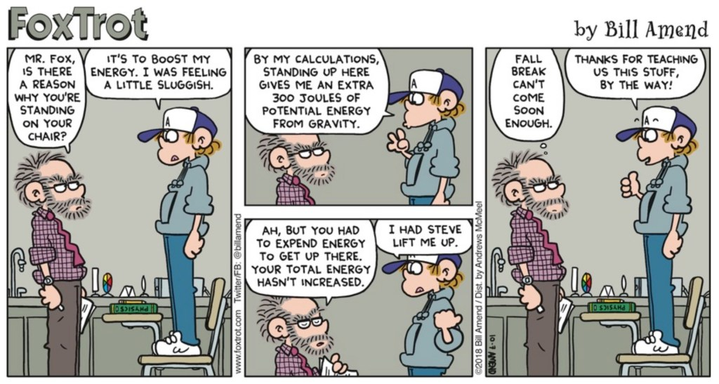
The Big Ban and the principle of conservation of energy

2015 Question 6 [Ordinary Level]
- Explain how the principle of conservation of energy applies to a roller-coaster.
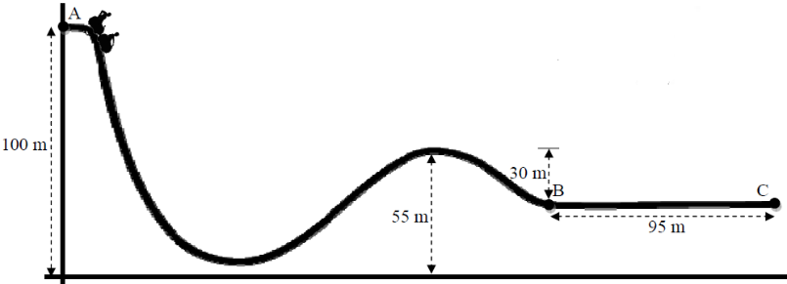
A roller-coaster car of mass 850 kg is released from rest at point A of the track, as shown in the diagram.

- Calculate the difference in height between point A and point B.
- Calculate the change in the potential energy of the car between A and B.
- Write down the kinetic energy of the car at point B, assuming there is no friction and no air resistance.
- Calculate its velocity at point B.
- The brakes are applied at point B and the car comes to a stop at point C.
Calculate the deceleration of the car between B and C.
- Calculate the average force required to bring the car to a stop.

Part (i) | Potential energy at top of roller-coaster is converted into kinetic energy as speed increases and height decreases.
Part (ii) | Calculate the difference in height between point A and point B.  Nice question. Use a ruler and pencil to note all heights on the left-hand side.  You should be able to show that the difference in height between A and B is 75 m.
Part (iii) | Change in potential energy = potential energy at A – potential energy at B  = mgh₁ – mgh₂  = (850)(9.8)(100) – (850)(9.8)(25)  = 624750 J
Part (iv) | Write down the kinetic energy of the car at point B.  The potential energy lost between A and B must equal the kinetic energy gained.  The car lost 624750 J of potential energy so gained the same amount of kinetic energy.  Kinetic energy at B = 624750 J.
Part (v) | Calculate its velocity at point B.  We know that the kinetic energy at point B is 624750 J and that the formula for kinetic energy is ½ mv².  ½ mv² = 624750 J ½ (850)v² = 624750 J v² = 1470 v = 38.3 m s⁻¹
Part (vi)  u = 38.3 m s⁻¹  v = 0  s = 95 m | Calculate the deceleration of the car between B and C.  v² = u² +2as 0 = (38.3)² + 2a(95)  (38.3)² = - 190a a = -7.7 m s⁻²
Part (vii)  m = 80 kg  a = 7.7 m s⁻¹ | F = ma F = (850)(7.7) F = 6545 N

2005 Question 12 (a) [Higher Level]
- A basketball of mass 600 g which was resting on a hoop falls to the ground 3.05 m below.
What is the maximum kinetic energy of the ball as it falls?
- On bouncing from the ground the ball loses 6 joules of energy.
What happens to the energy lost by the ball?
- Calculate the height of the first bounce of the ball.

Part (i)  m = 0.6 kg  g = 9.8 N kg⁻¹  h = 3.05 m | Potential energy at the top = kinetic energy at the bottom so to establish the kinetic energy at the bottom we really just need to calculate the potential energy at the top.  Potential energy at the top = mgh = (0.6)(9.8)(3.05) = 17.9 J  Kinetic energy at the bottom = 17.9 J
Part (ii) | It changes into sound and heat.
Part (iii) | The ball had 17.9 joules of energy when it hit the ground.  If it lost 6 J in the bounce then it must have 17.9 – 6 = 11.9 J as it starts to rise back up. This is its initial kinetic energy and as it moves upwards this kinetic energy is converted back into potential energy.  Kinetic energy at the bottom = Potential energy at the top  11.9 = mgh_{new}  $h_{new}=\frac{11.9}{(0.600)(9.8)}$ h_{new} = 2.02 m

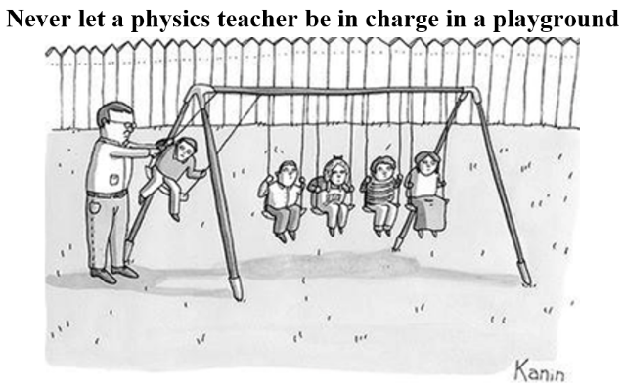

2018 Question 6 (c) [Higher Level]
During the pole vault event, an athlete has a horizontal speed of 9.2 m s^{–1} just before he jumps.
At his maximum height he has a horizontal speed of 1.1 m s^{–1}.
The athlete’s centre of gravity when he is standing is 98 cm above the ground.

During the vault, what is the maximum height above the ground to which he can raise his centre of gravity?

Solution
(kinetic energy + potential energy) at the start = (kinetic energy + potential energy) at the end

The athlete has a speed of 9.2 m s^{–1} just before he jumps so initial kinetic energy = (½)(m)(9.2)²
Initial potential energy = mgh_{bottom}

The athlete has a speed of 1.1 m s^{–1} at max height so final kinetic energy = (½)(m)(1.1)²
Final potential energy = mgh_{top}

(½)(m)(9.2)² + mgh_{bottom} = (½)(m)(1.1)² + mgh_{top}
Divide each term by m to get (½)(9.2)² + gh_{bottom} = (½)(1.1)² + gh_{top}

gh_{top} - gh_{bottom} = (½)(9.2)² – (½)(1.1)²

The athlete’s centre of gravity is 98 cm above the ground, so h_{bottom} = 0.98 m
(9.8)h_{top} – (9.8)(0.98) = (½)(9.2)² – (½)(1.1)² h_{top} = 4.26 m

h represents the height that his centre of gravity rises by, so we have to add on 0.98 m to find the height of his centre of gravity above the ground.

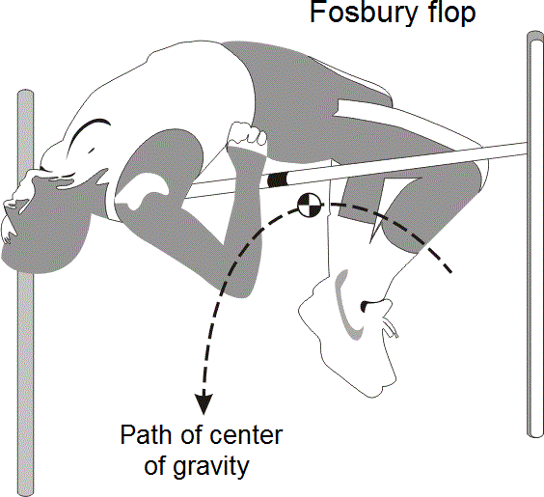
Answer: 4.26 + 0.98 = 5.24 m

The current technique used by just about all high-jump athletes was developed by Dick Fosbury who used it to win gold in the Olympic Games in Mexico City in 1968.
Notice firstly that the centre of gravity is outside the body and secondly, while the maximum height the centre of gravity can rise to is dictated by the athlete’s kinetic energy when jumping, they can still clear a bar which is higher still by arranging their body in the manner shown.

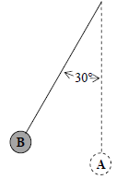
2013 Question 12 (a) [Higher Level]
The pendulum in the diagram is 8 m long with a small bob of mass 6 kg at its end. It is displaced through an angle of 30° from the vertical (position A) and is then held in position B, as shown.

- Calculate the height through which the bob has been raised .
- Calculate the potential energy that the bob has gained.
- The bob is then released and allowed to swing freely.
What is the maximum velocity it attains?

Part (i) | 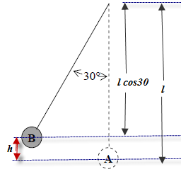  From the diagram h = (1 – l cos θ)  h = 8 – 8 cos 30 = 1.07 m
Part (ii) | Gain in potential energy = mgh = (6)(9.8)(1.07) = 63 J
Part (iii) | The bob’s maximum velocity will correspond to when it is at the very bottom. At this point it will have lost its potential energy which will be converted to kinetic energy.  Loss in potential energy = gain in kinetic energy.  mgh = ½mv²  63 = (½)(6)(v²)  v = 4.58 m s⁻¹

Power
Power is the rate at which work is done.
$$Power=\frac{work done }{time taken}$$

The unit of power is the watt (W).
One watt = one joule per second. 1W = 1 J s⁻¹

Note that any time work is being done it means that energy is being transferred or converted from one form to another, which leads to the following:
Power is the rate at which energy is converted from one form to another.
$$Power=\frac{energy transferred}{time taken}$$

In some contexts the work done may correspond to something being heated, in other contexts the work done will take the form of mechanical work, in which case we can use the fact that work = force × displacement,
$$Power=\frac{force × displacement}{time taken}$$

so mathematically we get

Remember the Work-Energy principle: The change in the energy of an object is equal to the work done on the object
So for these questions we could calculate the work done using the formula work = force × displacement
or we could say that the work done = energy gained = mgh.
2002 [Ordinary level]  A kettle uses 532 950 J to boil water.  If it takes 4 minutes calculate the power of the kettle. | Work done = 532 950 J  time = 4 minutes = 240 seconds  $power=\frac{work}{time}=\frac{532950}{240}$ = 2221 W
2007 [Ordinary level]  During a ten-hour period the energy gained by the bricks in a storage heater is 34.2 MJ.  Calculate the power of the heating coil. | Work done = 34.2 MJ = 34200000 J  time = 10 hours = (10)(60)(60) = 36000 seconds  $power=\frac{work}{time}=\frac{34200000}{36000}$ = 950 W
2019 Question 5 [Ordinary level]  A crane moves a load of weight 7000 N to  the top of a roof which is 4 m high.  The crane takes 20 seconds to do this work.  Calculate the power output of the crane. | $power=\frac{work}{time}= \frac{Fs}{t}=\frac{\left(7000\right)\left(4\right)}{20}$ = 1400 W
2016 Question 5 [Higher level]  A cyclist’s average power output when climbing a mountain is 280 W.  He completes the climb in 18 minutes. How much energy does he use? | Time = 18 minutes = 1080 seconds  $power=\frac{work}{time}$  work (or energy) = power × time  energy = 280 × 1080 = 302400 J

The work-energy principle and road fatalities
Remember the Work-Energy principle: The change in the energy of an object is equal to the work done on the object

Consider a car that needs to come to a complete stop to avoid a collision. How does the stopping distance relate to the car’s speed? Our first thought would be that if you doubled the car’s speed then the stopping distance would double also. But let’s look at it in a little more detail:
According to the Work-Energy principle, the change in the energy of an object is equal to the work done on the object.

If we want the car to come to a complete stop then work needs to be done on the car.
The kinetic energy of the car is given by the formula ½ mv² and the work done on the car to bring it to a stop is given by the formula W = F × s where F in this case represents the total frictional force and s is the stopping distance.
So we get ½ mv² = F × s

So where does that leave us? Well let’s now look at the relationship between stopping distance and speed.
F × s = ½ mv²
Which means that if we assume that the fricitonal forces and the mass (of the car) are constant then the stopping distance s is proportional to the square of the speed.

Let’s remind ourselves what that means:

If the speed increases from 10 mph to 20 mph (speed increases by a factor of 2) then the stopping distance increases by a factor of 4.
If the speed increases from 10 mph to 30 mph (speed increases by a factor of 3) then the stopping distance increases by a factor of 9.

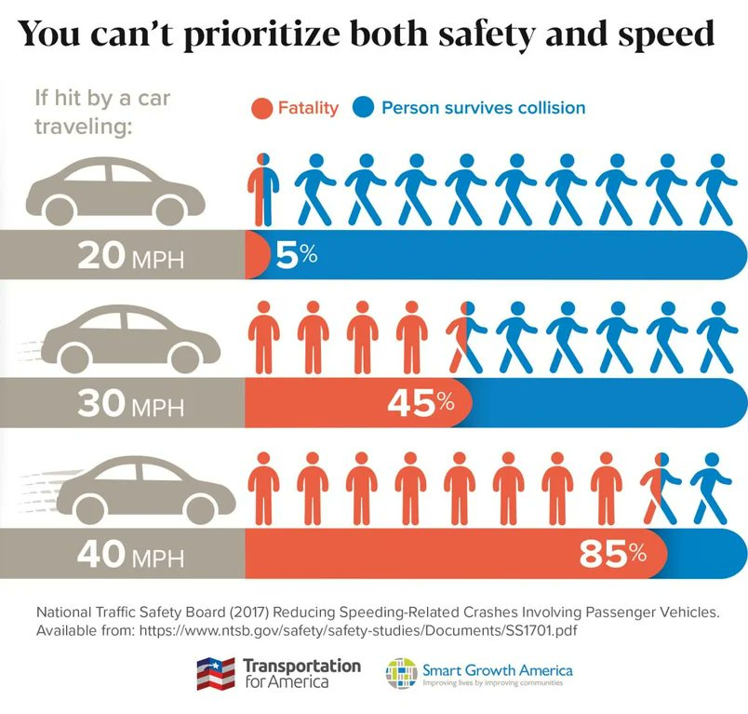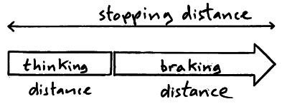

Of course you also have to factor in reaction time which, if you’re on your phone or looking anywhere other than on the road, means that either you’re dead by now or you have just killed someone.

2007 Question 6 [Ordinary Level]

An empty lift has a weight of 7200 N and is powered by an electric motor.
The lift takes a person up 25 m in 40 seconds.
The person weighs 800 N.

- Calculate the total weight raised by the lift’s motor.
- Calculate the work done by the lift’s motor.
- Calculate the power output of the motor.
- Calculate the energy gained by the person in taking the lift.
- If instead the person climbed the stairs to the same height in 2 minutes, calculate the power generated by the person in climbing the stairs.
- Give two disadvantages of using a lift.

Part (i) | 7200 + 800 = 8000 N
Part (ii) | Work = force × displacement = 8000 × 25 = 200000 J
Part (iii) | $power=\frac{work}{time}=\frac{200000}{40}$ = 5000 W
Part (iv) | The person weighs 800 N so mg = 800 N  Energy gained by the person = mgh = (800)(25) = 20000 J
Part (v) | Energy gained by the person is still 20000 J.  The time taken is 2 minutes = 120 seconds.  $power=\frac{work}{time}=\frac{200000}{120}$ = 166.6 W
Part (vi) | Needs electrical energy which uses fossil fuels and costs money.  No exercise so not good for health.

To estimate the power developed by a person running up a flight of stairs
- Calculate the work done in going up the stairs.
This will be the same as your potential energy at the top (mgh), where m is your mass (you will need a bathroom scales).
- Time how long it takes to run up a flight of stairs.
- Divide the work by the time taken.

2022 Deferred exam Question 6 [Higher level]  An athlete weighing 850 N runs up a stairs in 6 seconds. If the vertical height of the stairs is 2.5 m, calculate the average power generated by the athlete. | F = 850 N s = 2.5 m t = 6 s  $power=\frac{work}{time}= \frac{Fs}{t}=\frac{\left(850\right)\left(2.5\right)}{6}$ = 354 W  Alternatively you could have used W = mgh instead of W = Fs
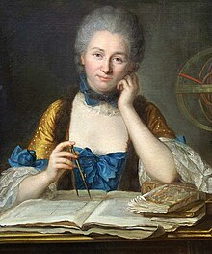


Émilie du Châtelet (1706 - 1749)

A fatality has occurred as a result of car-crash. Which concept is more helpful in figuring out what happened; conservation of momentum (just refers just to velocity) or the work-energy theorem (which refers to velocity squared)?

The concepts of momentum and impulse were well understood from the time of Newton, and the physics of collisions was mostly studied through that lens. Even the idea that momentum was conserved was well established. Energy however was a different story, particularly energy associated with moving objects (what we now refer to as ‘kinetic energy’). Newton thought, not unsurprisingly, that movement energy was proportional to speed or velocity and didn’t seem to have an opinion on whether or not it was conserved. Du Châtelet however had read the works of Gottfried Wilhelm Leibniz who proposed that energy was proportional to the square of the velocity of the moving object (and was also the first to propose the Work-Energy theorem. She proceeded to carry out experiments where she dropped objects from different heights into clay and determined that the depth of the indentation was proportional to the square of the velocity of the ball as it impacted the ground.

In one sense you could ask who cares whether it’s the velocity or the square of the velocity that counts, but that would be to ignore the importance of the concept of energy to all of physics. In fact it turned out that this very issue resulted in a split between the scientists of the day with British scientists mostly supporting Newton’s view while their European counterparts tended to side with Du Châtelet. Ultimately Du Châtelet would prove to be correct and she went on to develop the mv² term that we recognise today (the factor of ½ would could later) although like most female scientists she was completely overlooked when it came to recognising her achievements and it is only in recent years that her name has started to appear in physics textbooks.

So back to our initial question. Which factor should we be looking at; velocity or velocity squared?
The short answer is both. By knowing the length of the skid beforehand and the total frictional force (determined by the coefficient of friction between the road and the tyre) we can use F × s = ½ mv² to calculate v² and from that we can work out v and see if the driver was speeding before he hit the brakes.
But maybe the driver never used his brakes and hit a stationary car before moving off together. Now we can use conservation of momentum (which just involves velocity) to work out the speed that the first car was travelling at.

So what we now know, that scientists of the 17th and 18th century did not know, was that there are two very different concepts; energy and momentum, and both are conserved entities (in this universe at least).
That’s why I love the Newton’s Cradle demonstration. If one ball goes in then one goes out at the same speed (and momentum is conserved). If two go in then two go out at the same speed (and again momentum is conserved).
But why can’t one go out with twice the speed of the balls going in? It would still satisfy conservation of momentum but yet this never happens.

One more before we go:
You have been very bold and as your punishment you are going to have either a bowling ball or a marble fired at you. Assuming that both objects have the same momentum, which one would you rather be hit by (or does it make any difference)?

The kilowatt-hour
The kilowatt hour is used as a billing unit for energy delivered to consumers by electric utilities.
The concept is based around a rearrangement of the formula for power: Energy (or work) = power × time
One kilowatt hour is the amount of energy used by a 1000 watt appliance in one hour.
Number of kilowatt-hours = number of kilowatts × number of hours

2004 Question 9 [Ordinary Level]  Calculate the cost of using a 2 kW electric heater for 3 hours at 10 cent per kilowatt-hour. | Solution  No. of kW = 2  No. of hours = 3  No. of kWhours = no. of kilowatts × no. of hours  = (2 × 3) = 6 kW hours  Cost = 6 × 10 = 60 cent
2012 Question 8 [Ordinary Level]  A plug is used to connect an electrical appliance in the home to the 230 volt mains supply.  Modern plugs contain a small fuse which comes with a rating of 1A, 2A, 3A, 5A or 13A.  A vacuum cleaner has a power rating of 900 W.  - What is the most suitable fuse to use in the plug of the vacuum cleaner?  - If the vacuum cleaner is used for 90 minutes, calculate the number of units of electricity used.  - Calculate the cost of the energy used if the price of each unit of electricity is 22 cent. | Part (i)  P = 900 W, V = 230 V, P = VI  I = P/V = 900/230 = 3.9 A  The most suitable fuse is the one with a current rating just above 3.9 amps so a 5 amp fuse should be used.  Part (ii)  P = 900 W = 0.9 kW t = 90 minutes = 1.5 hours  No. of kWhours = no. of kilowatts × no. of hours  = (0.9 × 1.5) = 1.35 kW hours  Part (iii)  Cost = (1.35)(22) = 29.7 cent / 30 cent
2009 Question 8 [Ordinary Level]  Plugs are used to connect electrical appliances in the home to the 230 volt ESB supply. Modern plugs contain a small fuse which comes with a rating of 1A, 2A, 3A, 5A or 13A.  - A coffee maker has a power rating of 800 W.  What is the most suitable fuse to use in the plug of the coffee maker?  - If the coffee maker was in use for 150 minutes:  Calculate the number of units of electricity used by the coffee maker.  - Calculate the cost of the electricity used if each unit costs 15 cent. | Part (i)  P = 800 W, V = 230 V  P = VI I = P/V = 800/230 = 3.4 A  So the most suitable fuse is the 5 A fuse.  Part (ii)  P = 800 W = 0.8 kW t = 150 mins = 2.5 hours  No. of kWhours = no. of kilowatts × no. of hours  = 0.8 × 2.5  = 2 kW hours  Part (iii)  Cost = 2 × 15 = 30 cent

Percentage efficiency

Filament light bulbs have a percentage efficiency of approximately 5%.This means that if for every 100 joules of electrical energy that is converted to other forms in light bulb, only 5 joules are converted to light (the rest is heat, so it would be more accurate to refer to them as heatbulbs). CFL bulbs by comparison are 85% efficient, and LED bulbs are 90% efficient or better, so you can see why LED bulbs have now become the standard.
It’s also worth noting that no machine is 100% efficient – some energy is always ‘lost’ in the process, usually in the form of heat. This is why we can never have ‘perpetual motion’ machines. The percentage efficiency of petrol cars is between 20% and 40%.
$$Percentage Efficiency= \frac{useful power out}{power in} ×\frac{100}{1}$$

A 50 W LED lightbulb has a light power output of 45 W. Calculate the percentage efficiency rating of the lightbulb. | Solution  $\% Efficiency= \frac{useful power out}{power in} ×\frac{100}{1}$  $\% Efficiency= \frac{45 }{50} ×\frac{100}{1}$ = 90%
A 200 W LED lightbulb has a percentage efficiency rating of 90%. Calculate the light energy produced per second. | Solution  Power in = 200 W  Parentage efficiency = 90%  Light energy produced = 90% of 200 W = 180 W
2008 Question 7 [Higher level]
A toaster has a power rating of 1050 W when it is connected to the mains supply.
Calculate the heat generated by the toaster in 2 minutes if it has an efficiency of 96%.

Solution
Power = 1050 W
Time = 2 minutes = 120 seconds $power=\frac{work}{time}$

Work (or heat energy generate) = power × time
= 1050 × 120
= 126000 J
= 1.26 × 10⁵ J

96% efficiency means that 96% of this incoming energy (126000 J) is converted to heat energy (what happens to the other 4%?)
96% of 126000 = 121000 J = 1.21 × 10⁵ J

One of the scariest videos you will every watch, on built-in obsolescence in lightbulbs.
From veritasium; This is why we can't have nice things: Link

The solar constant
The solar constant is a measure of the energy from the sun falling on each square metre of the Earth’s surface in one second.

The average solar constant for the Earth has a value of 1360 W m⁻² (you don’t need to learn this number) but it can vary considerably from one country to another. It means that 1360 joules of solar energy fall on every square metre every second. The key to answering these questions is to look at the unit (W m⁻²). This is equivalent to joules per second per square metre, so to calculate the total energy falling you simply need to multiply the solar constant by the number of seconds and metres mentioned in the question.

2006 [Higher level]  The average value for the solar constant in Ireland is 120 W m^{–2}.  What is the average energy falling normally on an area of 5 m² of ground in Ireland in 1 minute? | 120 J of energy falls on every square metre per second.  So we have to multiply 120 by the number of square metres we have and also by the number of seconds.  Total energy = (120 × 5 × 60) = 36,000 J
2021 Question 11 [Ordinary Level]  The solar constant has a value of 1.36 kW m⁻².  On a particular day, sunlight falls on a garden  area of 54.0 square metres for exactly 12 hours.  Calculate how much energy will fall on the garden in the 12 hours. | 1360 joules of solar energy fall on every square metre every second.  So total energy falling on 54.0 m² over a period of 12 hours is  = 1360 × 54 × 60 × 60 × 12  = 3.17 × 10⁹ J
2015 Question 5 [Higher level]  Calculate the energy from the Sun falling on a football pitch of dimensions 106 m × 68 m in 90 minutes.  Solar constant = 1.36 kW m^{–2} | Time in seconds = 90 × 60 = 5400 s  Area =106 × 68 = 7208 m²  1.36 kW = 1360 joules per sec  1.36 kW m^{–2} means that 1360 joules of energy fall each second on one square metre.  So total energy falling = (1360)(5400)(7208) joules = 5.3 × 10¹⁰ J
2002 Question 5 [Higher level]  The solar constant is 1.35 kW m⁻².  What is the average amount of energy falling normally on each square metre of the earth’s atmosphere in one year? (one year = 3.16 × 10 ⁷s) | 1350 joules of energy falls on each m² in a second.  So in one year the number of joules that falls  = (1.35 × 10³)(3.16 × 10⁷)  = 4.27 ×10¹⁰ J
2007 Question 5 [Higher level]  A large number of solar cells are joined together in series and cover an area of 20 m².  The efficiency of the solar cells is 20%. If the solar constant is 1400 W m^{–2}, what is the maximum power generated by the solar cells? | Solar constant = 1400 W m^{–2}  Area = 20 m²  Maximum power = 1400 × 20 = 28000 W  But the efficiency of the solar cells is 20% so maximum power = 28000 × 0.2 = 5600 W

SLOP

Work
Define work and give the unit of measurement. | Work is the product of force by displacement.  The joule
Energy
Define energy and give the unit of measurement. | Energy is the ability to do work.  The joule
State the principle of conservation of energy. | The principle of conservation of energy states that energy cannot be created or destroyed but can only be converted from one form to another.
Define kinetic energy | Kinetic energy is energy an object has due to its motion.
What type of energy is associated with wind, waves and moving water? | Kinetic energy
Give one disadvantage of non-renewable energy sources. | They will run out.
How does the sun produce heat and light? | Through nuclear reactions.
State one energy conversion that takes place in an electrical generator. | Kinetic to electric.
What energy conversion takes place when a fuel is burnt? | Chemical to heat.
What energy conversion takes place in a solar panel? | Light to electricity
Why is a fluorescent tube an efficient source of light? | Most of the (electrical) energy is converted to light (energy)
Why is a filament light bulb not an efficient source of light? | Almost all of the energy is given off as heat.
What is the difference between potential energy and kinetic energy? | Potential energy is energy a body has due to its position; kinetic energy is energy a body has due to its motion.
Give one factor on which the potential energy of a body depends. | Mass, height, gravitational field strength (g).
Power
Define power and give the unit of measurement. | Power is the rate at which work is done.  The watt.
The solar constant
What is the max energy that can fall on an area of 8 m² in one hour if the solar constant is 1350 W m^{–2}? | 1350 × 8 × 3600  E_{max} = 3.9 × 10⁷ J

2: DENSITY AND PRESSURE

Something to think about
- You may have noticed while pouring a liquid into a bottle through a funnel that you have to lift the funnel from time to time when the liquid collects in the funnel and does not flow down. Do you know why?

- We will see when we study the chapter on Heat that water boils at 100 ⁰C at normal atmospheric pressure. Can you explain why it will boil at a temperature less than 100 ⁰C if the atmospheric pressure is low?
- The type of weather we get depends on the atmospheric pressure.
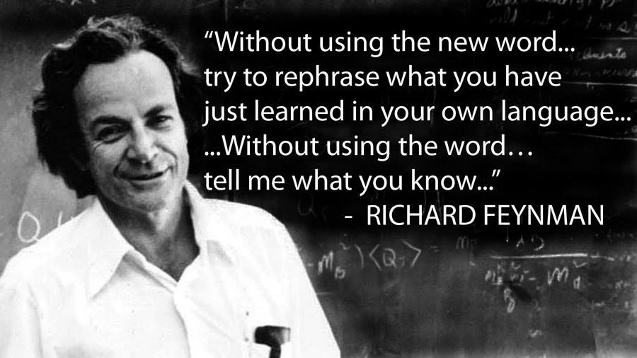
Describe the kind of weather we get when the atmospheric pressure is high. [2005 OL]
Explain your answer .
- Can you explain, without using the words ‘pressure’ or ‘suck’, why a liquid (e.g. coke) rises up through a straw when you drink?
- When one door closes another one opens.
Forget inspirational quotes – this is just atmospheric pressure. But why?

Student Notes

Density
Density is defined as mass per unit volume.
$$density= \frac{mass}{volume}$$

We represent this mathematically as follows:
The symbol for density is ρ (pronounced ‘row’)
The unit of density is usually listed in kg m⁻³ or g cm⁻³

The most difficult part of these questions usually relates to having to convert from cm³ to m³.
Note that there are one million cm³ in one m³.

Before proceeding you should first revisit scientific notation
1 m³ = 1×10⁶ cm³ 1 cm³ = 1×10⁻⁶ m³

2010 HL Question 5 [Ordinary level]  A concrete mixer delivered 50 m³ of concrete to a building site, what was the mass of the concrete delivered?  (density of concrete = 2400 kg m⁻³) | $$Density=\frac{mass}{volume}$$  mass = density × volume  mass = 2400 × 50  = 120000 kg
2019 HL Question 5  An apple has a weight of 1 N and its volume is 121 cm³.  Calculate the density of the apple.  (acceleration due to gravity = 9.8 m s^{–2}) | W = mg $m=\frac{1}{9.8}$ = 0.102 kg = 102 g  $$ρ=\frac{m}{v}=\frac{102}{121}$$  = 0.843 g cm⁻³
Calculate the mass of a cube of ice, of side 2.5 cm (density of ice = 0.92 g cm^{–3}) | $Density=\frac{mass}{volume}$  Mass of one cube = (density)(volume)  = (0.92)((2.5×2.5×2.5)  = 14.375 g = 0.014.375 kg
Calculate the mass of 500 litres of water  (density of water = 1000 kg m^{–3})  There are one thousand litres in one cubic metre, so 1 litre = 1 × 10^{–3} m³ | 500 litres of water = 500 × 10^{–3} m³  Mass of 500 litres of water = (density)(volume)  = (1000)(500 × 10^{–3})  = 500 kg
2022 Question 5  Iron has a density of 7.87 g cm^{–3}.  An iron sphere has a mass of 500 g.  Calculate the radius of the sphere in cm. | In this question we are given the density in g cm^{–3} and mass in grams (g). So we can proceed with these numbers and units but we just need to remember that when we find the radius it will be in cm.  $density (ρ)=\frac{mass (m)}{volume (v)}$  $volume=\frac{mass}{density}$ $=\frac{500}{7.87}$ = 63.53 cm³  $volume= {\frac{4πr}{3}}^{3}$ $63.53= {\frac{4πr}{3}}^{3}$  r = 2.475 cm

2020 Question 5  A neutron star has a density of 3.7 × 10¹⁷ kg m^{–3}.  What would the radius of the Earth be if it had the same density as the neutron star?  (mass of Earth = 6.0 × 10²⁴ kg) | $density (ρ)=\frac{mass (m)}{volume (v)}$  $volume=\frac{mass}{density} =\frac{{6.0×10}^{24}}{3.7 × {10}^{17}}$ = ${1.62×10}^{7}$ m³  $volume= {\frac{4πr}{3}}^{3}$ ${1.62×10}^{7}= {\frac{4πr}{3}}^{3}$ r = 157 m
$Why is density= \frac{mass}{volume}$?

Why would we ever want to know what the density of an object is? One reason is to see whether or not the object would sink or float in water. See below for some everyday examples:

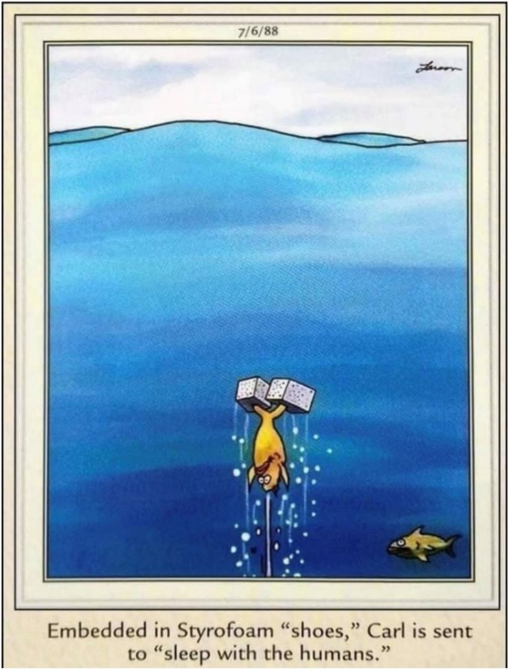

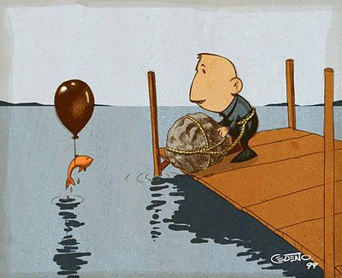

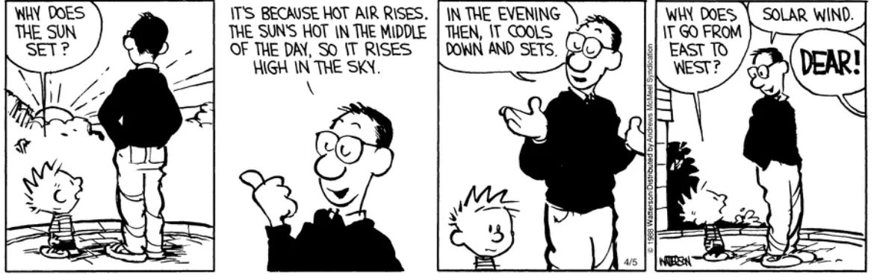

Pressure
Pressure is defined as force per unit area.
$$pressure= \frac{force}{area}$$

We represent this mathematically as follows:

The symbol for pressure is P. The unit of pressure is the pascal (Pa)

Pressure is a scalar quantity (it does not have a direction associated with it).

The most difficult part of the maths questions associated with this formula usually relates to having to convert from cm² to m².
Note that there are ten thousand cm² in one m² and one million (1000 × 1000) mm² in a m².

1 m² = 1×10⁴ cm² 1 cm² = 1×10⁻⁴ m²

Pressure exerted by a solid material

2008 Question 5 [Ordinary level]  A solid block in the shape of a cube of length 120 cm rests on a table.  The weight of the block is 25 N.  Calculate the pressure it exerts on the table. | Force = weight = 25 N area = 1.2 m²  $$Pressure= \frac{Force}{Area}= \frac{25}{{1.2}^{2}}$$  P = 17.4 Pa
2008 Question 5 [Higher level]  The head of a thumbtack has an area of 500 mm².  Its point has an area of 0.3 mm². The pressure exerted at the head of the thumbtack is 12 Pa.  What is the pressure exerted at the point of the thumbtack?  Note  The key to this question is the fact that while the pressure changes (as a result of the area over which the force is exerted changing), the force itself is constant. This seems to be the first and only time that this concept was expected to be known). | So 1 mm² = 1 × 10⁻⁶ m².  500 mm² = 500 × 10⁻⁶ m²  0.3 mm² = 500 × 10⁻⁶ m²  $Pressure= \frac{Force}{Area}$  ⇒ Force = (Pressure)(Area)  At the head: F = Pressure × Area  ⇒ F = (12)(500 × 10⁻⁶) ⇒ F = 6.0 × 10⁻³ N  At the point:  $Pressure= \frac{Force}{Area}$ = $\frac{{6.0 ×10 }^{-3}}{0.3 ×{10}^{-6} }$ = 2.0 × 10⁴ Pa
2005 Question 5 [Higher level]  A container contains 5.0 kg of water. If the area of the base of the container is 0.5 m². Calculate the pressure at the base of the container due to the water. | $Pressure=\frac{force}{area}$  The force corresponds to the weight mg. $P=\frac{mg}{area}$ $P=\frac{(5.0)(9.8)}{0.5}$  ⇒ P = 98 Pa
Pressure in a fluid

The difference in pressure (ΔP) between two points in a fluid depends upon:
- the density of the liquid (ρ)
- acceleration due to gravity (g)
- the difference in height between the two points (Δh)

ΔP = ρgΔh

Worked solutions
2004 [Higher level]  A can of height 10 cm is submerged in water.  What is the difference in pressure between the top and bottom of the can?  (density of water = 1000 kg m⁻³) | Change in pressure ΔP = ρgΔh  ⇒ ΔP = (1000)(9.8)(0.1)  ΔP = 980 Pa
2021 Question 5 [Higher level]  Water has a density of 997 kg m⁻³.  Calculate the pressure due to water at a depth of 214 m. | ΔP = ρgΔh = (997)(9.8) (214)  ΔP = 2.1 × 10⁶ Pa
2009 Question 12 (a) [Ordinary Level]  A diver is swimming at a depth of 5m.  He then dives deeper until he reached a depth of 30 m. Calculate the increase in pressure on the diver at this new depth  (density of water = 1000 kg m⁻³) | ΔP = ρgΔh  ΔP = (1000)(9.8)( (25)  ΔP = 2.45 ×10⁵ Pa

Pressure in a fluid increases with depth

Demonstration
Set up as shown.
The water coming out of the bottom hole travels the farthest, because it is under the greatest pressure.

Applications
Hydrometers: Used to measure the density of liquids

Upthrust

Consider an object (in this case a rubber duckie) floating in water. There is obviously a gravitational force acting downwards, but if the lickle duckie is just sitting there then there must be an equal and opposite force acting upwards. This force is called upthrust.

2023 Deferred Question 7 Higher Level
Draw a force diagram to show the forces acting on a balloon as it rises through the water.
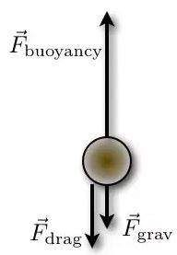
Answer: See diagram.

The drag force represents the force of friction which acts against the balloon ascending through the water.
Because the balloon is rising upwards the upward force must be equal to or greater than the sum of the downward forces. Therefore the upward arrow needs to be as long as or longer than the other two lengths added together.

Archimedes’ principle
Archimedes’ principle states that when an object is immersed in a fluid, the upthrust it experiences is equal to the weight of the displaced fluid*.
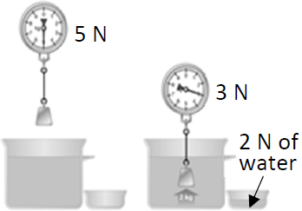
2023 Deferred Question 7: Describe a laboratory experiment to demonstrate Archimedes’ principle.

Method
- Weigh an object in air using a newton balance – in this case it weighs 5 N.
- Fill an overflow can to the brim and immerse the same object in the can. Note the new weight – in this case it now weighs 3 N.
- Find the weight of fluid displaced – in this case it weighs 2 N.

Result: (Weight of object in air – Weight of object in water) = Weight of fluid displaced

Conclusion
The upthrust experienced by the stone is equal to the weight of the displaced fluid.

The law of flotation

The law of flotation states that the weight of a floating object is equal to the weight of the fluid it displaces.

2022 Higher level  Draw a labelled diagram to show the forces acting on a piece of wood floating at rest. | 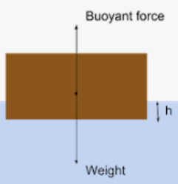  Weight downwards  Buoyancy/upthrust upwards  Equal and opposite force vectors

You can tell the sex of an ant by dropping it in water.
If it sinks, girl ant.
If it floats, buoyant.

Three guys are on a boat and they have four cigarettes but no lighters or matches or anything to light them with.
What do they do?
Answer: They throw one cigarette overboard and the whole boat becomes a cigarette lighter.

Einstein, Newton and Pascal are hanging out in the afternoon.
Einstein is bored so he suggests, “Let’s play hide and seek. I’ll be ‘it’”.
The others agree, so Einstein begins counting. “One . . . Two . . . Three . . .”
Pascal runs off right away to find a place to hide.
But Newton merely takes out a piece of chalk and draws a mid-sized square.
He finishes and steps into the square just as Einstein shouts, “Ready or not – here I come!”
Einstein looks up and immediately spots Newton standing right in front of him.
He says, “I found you, Newton!”
Newton replies, “No, you found one Newton per square meter – You found Pascal!”

Pressure in a gas: Boyle’s Law
You must remember to include the phrases ‘at constant temperature’ and ‘fixed mass of gas’.
Boyle’s Law states that at constant temperature, the volume of a fixed mass of gas is inversely proportional to its pressure.

Mathematically
$P∝ \frac{1}{V}$ ⇒ $P=k \frac{1}{V}$ ⇒ $PV=k$
So if the pressure of a gas goes up, the volume goes down in the same proportion, which we represent mathematically as follows:
$$p_{1}v_{1}= p_{2}v_{2}$$

Most maths questions on this topic are based around that formula

A balloon rises through the atmosphere while the temperature remains constant.  The volume of the balloon is 2 m³ at ground level where the pressure is 1000 hPa.  Find the volume of the balloon when it has risen to a height where the atmospheric pressure is 500 hPa.  {1 hPa = 100 Pa but technically even if you didn’t know this you would still get the correct answer because it’s the same multiple on both sides.} | P₁V₁ = P₂V₂  ⇒ (1000 ×10²)(2) = (500 ×10²)(V₂)  ⇒ V₂ = (1000 ×10²)(2) ÷ (500 ×10²) = 4 m³  Alternatively we could just refer to $P∝ \frac{1}{V}$  In this case the pressure has decreased by a factor of 2 (got 2 times smaller) so the volume gets 2 times bigger.
A small bubble of gas rises from the bottom of a lake. The volume of the bubble increases threefold when it reaches the surface of the lake where the atmospheric pressure is 1.01 × 10⁵ Pa.  Calculate the pressure at the bottom of the lake. | volume at top = 3 × volume at bottom  pressure at bottom = 3 × pressure at top  pressure at bottom = (3)(1.01 × 10⁵)  pressure at bottom = 3.03 × 10⁵ Pa
Calculate the depth of the lake in the previous question.  (density of water = 1000 kg m⁻³) | ΔP = ρgΔh  Pressure at bottom of lake = 3.03 × 10⁵ Pa  Pressure at top of lake = 1.01 × 10⁵ Pa  Change in pressure = ΔP = 2.02 × 10⁵ Pa  Now we need to find h:  ΔP = ρgΔh  2.02 × 10⁵ = (1000)(9.8)(Δh)  $Δh=\frac{{2.02 × 10}^{5}}{(1000)(9.8)}$  Δh = 20.61 m

VERIFICATION OF BOYLE’S LAW
APPARATUS
Boyles’ Law apparatus (see diagram)

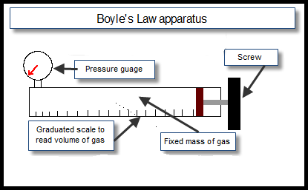
DIAGRAM

PROCEDURE
- The tube is filled with air.

- Note the pressure of the gas from the pressure-gauge and the volume from the graduated scale.

- Turn the screw to decrease the volume and increase the pressure.

- Note the new readings and repeat to get about seven readings.

- Draw a graph of pressure against 1/volume – see next page.

RESULTS
Pressure (Pa)

Volume (m³)

1/volume (m⁻³)

CONCLUSION
We followed the steps, plotted the graph and did indeed get a straight line through the origin, thus verifying that pressure is inversely proportional to volume.

PRECAUTIONS / SOURCES OF ERROR
- Wait a minute for temperature (and therefore volume) to stabilise after each pressure change before you read the volume.
- Have your eye level with the dial on the pressure gauge when taking readings to avoid parallax error.
- Work in a room where the temperature remains constant throughout the experiment (clutching at straws here).

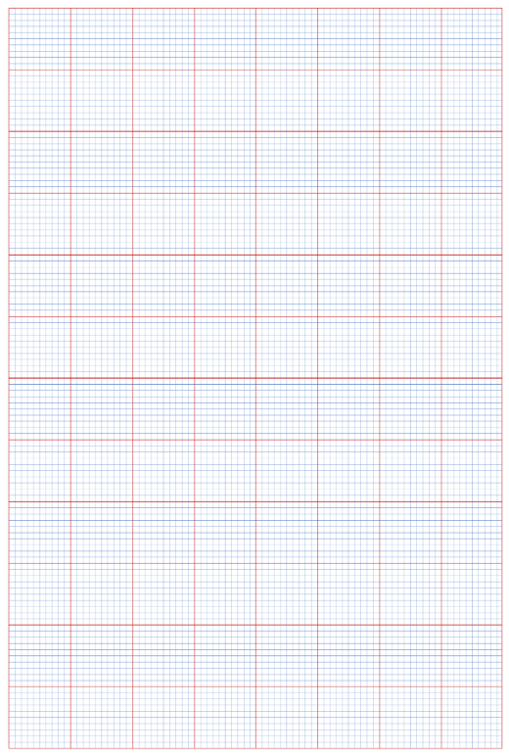
Graph of pressure against volume for constant mass of gas

Theory questions

Draw a labelled diagram of the apparatus
Describe how the student obtained the data | Note the pressure of the gas from the pressure-gauge and the volume from the graduated scale.  Turn the screw to decrease the volume and increase the pressure.
Why might the temperature of the gas have changed significantly during the experiment? | Changing the volume (or pressure) quickly would cause a change in temperature of the gas.
Draw a suitable graph to show the relationship between the pressure of the gas and its volume.

Explain how your graph verifies Boyle’s law. | Straight line through origin shows that pressure is inversely proportional to volume
Use your graph to estimate the pressure of the gas at a volume of 260 cm³.

How did the student ensure that the temperature of the gas was the same for each measurement? | Release the gas pressure slowly / allow time between readings.
Why should there be a delay between adjusting the pressure of the gas and recording its value? | To allow for the gas to cool (reach thermal equilibrium with the environment)
Give one other precaution that the student took in carrying out the experiment. | Avoid parallax error when taking readings.

Related exam questions
HL: 2015, 2013, 2011, 2003 OL: 2004

[2004 OL]
In an experiment to verify Boyle’s law, a student measured the volume of a gas at different pressures.
The table shows the measurements recorded by the student.
pressure /kPa | 100 | 111 | 125 | 143 | 167 | 200 | 250
volume /cm³ | 5.0 | 4.5 | 4.0 | 3.5 | 3.0 | 2.5 | 2.0
1/volume /cm⁻³ |  |  | 0.25

- Draw a labelled diagram of the apparatus used in this experiment.
- Copy this table and fill in the last row by calculating 1/ volume for each measurement.
- Plot a graph on graph paper of pressure against 1/volume.
- Explain how your graph verifies Boyle’s law.
- Give one precaution that the student took in carrying out the experiment.

[2013 HL]
In an experiment to verify Boyle’s law, a student took the set of readings given in the table below.
X | 120 | 160 | 200 | 240 | 280 | 320
Y | 52 | 39.1 | 31.1 | 25.9 | 22.2 | 19.6

- What physical quantities do X and Y represent?
- Name the units used when measuring these quantities.
- Draw a labelled diagram of the apparatus that the student used in the experiment.
- Describe the procedure he used to obtain these readings.
- Use the data in the table to draw an appropriate graph on graph paper.
- Explain how your graph verifies Boyle’s law.

[2011 HL]
During an experiment to verify Boyle’s law, the pressure of a fixed mass of gas was varied.
A series of measurements of the pressure p and the corresponding volume V of the gas was recorded as shown. The temperature was kept constant.
p/kPa | 325 | 300 | 275 | 250 | 200 | 175 | 150 | 125
V/cm³ | 12.1 | 13.0 | 14.2 | 15.5 | 19.6 | 22.4 | 26.0 | 31.1

- Draw a labelled diagram of the apparatus used in the experiment.
- How was the pressure of the gas varied during the experiment?
- Describe how the pressure and the volume of the gas were measured.
- Why should there be a delay between adjusting the pressure of the gas and recording its value?
- Draw a suitable graph to show the relationship between the pressure and the volume of a fixed mass of gas.
- Explain how your graph verifies Boyle’s law.

Adapted table of data

2004 OL
Pressure /kPa | 100 | 111 | 125 | 143 | 167 | 200 | 250
Volume /cm³ | 5.0 | 4.5 | 4.0 | 3.5 | 3.0 | 2.5 | 2.0
1/Volume /cm⁻³ | 0.20 | 0.22 | 0.25 | 0.28 | 0.33 | 0.40 | 0.50
2013
p/kPa | 120 | 160 | 200 | 240 | 280 | 320
V (cm³) | 52 | 39.1 | 31.1 | 25.9 | 22.2 | 19.6
1/ V (cm⁻³) | 0.019 | 0.026 | 0.032 | 0.039 | 0.045 | 0.051
2011
p/kPa | 325 | 300 | 275 | 250 | 200 | 175 | 150 | 125
V/cm³ | 12.1 | 13.0 | 14.2 | 15.5 | 19.6 | 22.4 | 26.0 | 31.1
1/V (cm⁻³) | 0.0826 | 0.0769 | 0.0704 | 0.0645 | 0.0510 | 0.0446 | 0.0385 | 0.0322
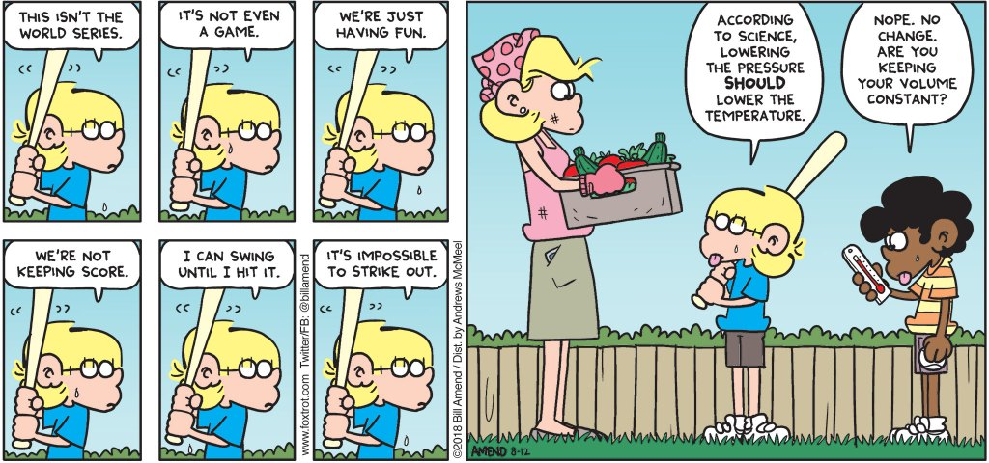
Extra reading

Boyle’s Law states that at constant temperature, the volume of a fixed mass of gas is inversely proportional to its pressure.
Here’s a simple activity to demonstrate that pressure affects temperature:
Place the palm of your hand a couple of inches from your mouth, purse your lips and blow; notice how nice and cool it is?
Now do the same thing, except this time ‘haw’ on the hand, i.e. leave your mouth wide open as you expel the air. Notice how much warmer it is.
Now go back to the first stage again, only this time bring your hand right up to your mouth when you blow. This time it seems cool again!
I was going to leave it as an exercise for you to explain how the same air can be at two different temperatures on reaching your hand, but that would be a little disingenuous given that I don’t understand it myself. Obviously it has something to do with pressure, and I think words like ‘adiabatic’ and ‘expansion’ are invoked somewhere along the line, but that’s not an explanation is it?
The point is that pressure, volume and temperature are all interlinked and if you wish to establish a relationship between any two of them you must keep the third variable constant.
I’ve put up a number of videos on YouTube describing this in more detail. Go to the interactive links page of thephysicsteacher to find them.

Robert Boyle
Boyle (from Waterford) was also the first to demonstrate that the sound of a bell in a bell jar faded as the air was removed. This proved that the air was necessary for the transmission of sound.
Besides being a busy natural philosopher, Boyle devoted much time to theology, showing a very decided leaning to the practical side and an indifference to controversial polemics. He founded the Boyle lectures, intended to defend the Christian religion against those he considered "notorious infidels, namely atheists, theists, pagans, Jews and Muslims," with the proviso that controversies between Christians were not to be mentioned.

Would an astronaut explode in space if they didn’t have a space-suit?
Provided that you do not hold your breath, exposure to vacuum for 5 to 10 seconds is unlikely to produce permanent injury (although it may cause problems in the eardrum).
Some degree of consciousness would be maintained for up to 15 seconds, which is about the time it takes oxygen-deprived blood to go from the lungs to the brain. During this time, the person exposed to the vacuum may become aware of the water on their tongue beginning to boil. As time progresses injury would accumulate as the evaporation of water vapour causes the body to swell and cool. After four minutes they would finally succumb to asphyxia as the brain cannot survive without oxygen. But they would not explode, thanks to the containing effect of the skin and the circulatory system.

Pressure and boiling point
Is it true that you can’t make a decent cup of tea up a mountain?
As you ascend a mountain, the air pressure decreases and you find yourself gasping for oxygen as well as a nice cuppa. Unfortunately as the pressure decreases, liquid water finds it easier and easier to turn into a gas, in other words to boil. At sea level, water boils at 100°C but by the time you’ve reached the top of Everest your kettle will boil at just 72°C.
Which is not nearly hot enough to make a decent cup of tea.

The ‘bends’
Due to nitrogen in our blood coming out of solution when the pressure drops quickly and forming little gas bubbles which can lodge in an artery preventing the movement of oxygen, causing severe pain or even brain damage.

Things that make you go Hmmmmmmm ….
Robert Boyle was one of the first to investigate/appreciate atmospheric pressure. He declared that we were all ‘living under a sea of air’.

High pressure is associated with good weather. This is because the ‘blanket of air’ is heavy and it is therefore harder for water molecules to evaporate. There is now less water vapour in the air, so less clouds, which means less rain and more sunlight. So there.

Atmospheric pressure is taken as 100,000 Pa (1 x 10⁵ Pa). Because one pascal is equivalent to one newton per square metre, we can say atmospheric pressure is equal to 100,000 newtons per square metre. Now there are 10,000 square cms in a square metre (100 cm x 100 cm), so therefore one square cm of paper will have a force of 10 Newtons (100,000 divided by 10,000) – equivalent to one kilogram - acting down on it from the atmosphere. Or to make it more realistic, if you draw a square, with each side 10 cm long, that gives you an area of 100 square cm (about the area of the top of your head?), and therefore a force acting downwards (due to atmospheric pressure) of 1,000 Newtons, equivalent to 100 kg. Remember an average student’s weight would be about 80 kg. And this is acting on each and every one of us every day!

Bottom-dwelling fish cannot survive on the ocean surface. Some fish can adapt to the different pressures, but I’m not sure how.

Aircraft are pressurised, which explains why passengers get ‘sucked out’ of a plane if the door gets blown off at high altitudes.

I recall a quote from Charles Darwin who was describing his extreme discomfort on climbing a particular high-altitude mountain: “I began to bleed through every orifice in my body”.

If a large truck passes you out at speed (if you’re walking or cycling) you can get ‘sucked in’ to its slip-stream.

If you are ever unfortunate enough to be in a car which falls into a lake, and are trying to open the doors, you be unable to do so until you first let down the window to let in a large amount of water which goes someway to equalising the pressure.

Many liquid containers have two holes which help the liquid to pour out smoothly; one for the liquid out, the other to allow the air to get in without disturbing the flow of liquid. See for example Tetra Pack cartons. Try to empty a two-litre bottle of water and see how long it takes. A much quicker method is to create a ‘mine tornado’ where the air goes up the middle as the water goes down the outside. Quite impressive!
The effect is noticeable if you try to put water into a container which has a small hole on top, like a hot-water bottle! Have you ever tried it? What happens? Would it be any different if you were putting in cold water? See the model of a pair of lungs to demonstrate how we can ‘suck’ up liquids (and air).

The Barometer Story

Some time ago I received a call from a colleague who asked if I would be the referee on the grading of an examination question. He was about to give a student a zero for his answer to a physics question, while the student claimed he should receive a perfect score and would if the system were not set up against the student. The instructor and the student agreed to submit this to an impartial arbiter, and I was selected.
I went to my colleague's office and read the examination question, "Show how it is possible to determine the height of a tall building with the aid of a barometer."
The student had answered, "Take a barometer to the top of the building, attach a long rope to it, lower the barometer to the street and then bring it up, measuring the length of the rope. The length of the rope is the height of the building."

I pointed out that the student really had a strong case for full credit since he had answered the question completely and correctly. On the other hand, if full credit was given, it could well contribute to a high grade for the student in his physics course. A high grade is supposed to certify competence in physics, but the answer did not confirm this. I suggested that the student have another try at answering the question. I was not surprised that my colleague agreed, but I was surprised that the student did.
I gave the student six minutes to answer the question with the warning that the answer should show some knowledge of physics. At the end of five minutes, he had not written anything. I asked if he wished to give up, but he said no. He had many answers to this problem; he was just thinking of the best one. I excused myself for interrupting him and asked him to please go on. In the next minute he dashed off his answer which read, "Take the barometer to the top of the building and lean over the edge of the roof. Drop that barometer, timing its fall with a stopwatch. Then using the formula S = ½at², calculate the height of the building."
At this point I asked my colleague if he would give up. He conceded, and I gave the student almost full credit.
In leaving my colleague's office, I recalled that the student had said he had many other answers to the problem, so I asked him what they were. "Oh yes," said the student. "There are a great many ways of getting the height of a tall building with a barometer. For example, you could take the barometer out on a sunny day and measure the height of the barometer and the length of its shadow, and the length of the shadow of the building and by the use of a simple proportion, determine the height of the building."
"Fine," I asked. "And the others?"
"Yes," said the student." There is a very basic measurement method that you will like. In this method you take the barometer and begin to walk up the stairs. As you climb the stairs, you mark off the length of the barometer along the wall. You then count the number of marks, and this will give you the height of the building in barometer units. A very direct method."
"Of course, if you want a more sophisticated method, you can tie the barometer to the end of a string, swing it as a pendulum, and determine the value of 'g' at the street level and at the top of the building. From the difference of the two values of 'g' the height of the building can be calculated."
Finally, he concluded, there are many other ways of solving the problem. "Probably the best," he said, "is to take the barometer to the basement and knock on the superintendent's door. When the superintendent answers, you speak to him as follows, 'Mr. Superintendent, here I have a fine barometer. If you tell me the height of this building, I will give you this barometer.'"
At this point I asked the student if he really did know the conventional answer to this question. He admitted that he did, said that he was fed up with high school and college instructors trying to teach him how to think, using the "scientific method"…

SLOP

A concrete mixer delivered 50 m³ of concrete to a building site, what was the mass of the concrete delivered?  (Density of concrete = 2400 kg m⁻³) | m = 2400 × 50 = 120000 kg
Define pressure. | Pressure = Force ÷ area.
Give the unit of pressure. | The unit of pressure is the pascal.
Is pressure a vector quantity or a scalar quantity? Justify your answer. | It is a scalar because it has no direction.
Mathematical pressure
Name an instrument used to measure pressure. | The barometer.
The wind exerts a horizontal force of 1000 N on a wall of area 20 m². Calculate the pressure at the wall. | P = F/A  = 1000/20  = 50 Pascals
A container contains 5.0 kg of water. If the area of the base of the container is 0.5 m².  Calculate the pressure at the base of the container due to the water. [2005] | - P = F/A = [ (5.0)(9.8)/(0.5)]  - ⇒ P = 98 Pa
The African elephant is the largest land animal.  An elephant weighs 40 000 N and is standing on all four feet each of area 0.2 m².  Calculate the pressure exerted on the ground by the elephant. | P = F/A  ⇒ P = 40 000/0.8  ⇒ P = 5,000 Pa.
Why would the pressure on the ground be greater if the elephant stood up on just two feet? | The area would be smaller.
Atmospheric Pressure
Describe an experiment to show that the atmosphere exerts pressure. | Apparatus: glass of water and cardboard.  Procedure: place cardboard over glass and invert.  Observation/conclusion: water remains in glass.
When air is removed from a container it collapses. Explain why. | The pressure outside (due to atmospheric pressure) is greater than the pressure inside.
The earth is covered with a layer of air called the atmosphere.  What holds this layer of air close to the earth? | Gravity.
Pressure in a liquid
Describe an experiment to show that the pressure in a liquid increases with depth. | Set up as shown.  Note that the water coming out of the hole at the bottom travels the farthest because it is under the greatest pressure.
Name an instrument used to measure the density of a liquid. | A hydrometer
State Archimedes’ principle. | When an object is immersed in a fluid, the upthrust it experiences is equal to the weight of the displaced fluid.
State the law of flotation. | When a body floats in a liquid its weight is equals the weight of fluid displaced.
A diver is swimming at a depth of 5m. He then dives deeper until he reached a depth of 30 m. Calculate the increase in pressure on the diver at this new depth  (density of water = 1000 kg m⁻³) | ΔP = ρgΔh  ΔP = (1000)(9.8)( (25)  = 2.45 ×10⁵ Pa
Boyle’s Law
State Boyle’s law | Boyle’s Law states that pressure is inversely proportional to volume for a fixed mass of gas at constant temperature.
A balloon rises through the atmosphere while the temperature remains constant.  The volume of the balloon is 2 m³ at ground level where the pressure is 1000 hPa.  Find the volume of the balloon when it has risen to a height where the atmospheric pressure is 500 hPa. | P₁V₁ = P₂V₂  ⇒ 1000 × 2 = 500 × V₂  ⇒ V₂ = (1000 × 2)/500 = 4 m³

The science of learning quiz: Part 10

  - We don’t tend to think of memory as having a set of rules by which it operates, but when you think about it, it must have. On what basis does it decide to store or discard information received?

  - How many study techniques can you think of which involve retrieval?

  - What is ‘The forgetting curve’ (also known as ‘The Ebbinghaus forgetting curve’)?
Sketch it in as much detail as you can.

Answers

- We don’t tend to think of memory as having a set of rules by which it operates, but when you think about it, it must have. On what basis does it decide to store information?
The way that we learn new information has not changed since our brains evolved hundreds of thousands - or even millions - of years ago. And back then it was evolving in response to factors that didn’t involve learning definitions ‘off by heart’. So why should it change just because in the past few hundred years it became important to learn differently? Why should we be so arrogant as to think that our brain is designed specifically for our current needs? So what rule(s) does it use?
Each time your brain recalls (retrieves) the information it causes the connections responsible for maintaining the information to become more secure. On the other hand if the information is never recalled then the connections never become strong enough to form a secure memory and after a short time no more recall is possible. The time interval between first encounter and last chance to retrieve obviously depends on a whole series of factors, including the level of complexity of the concept at hand.
at any stage, and if you have, how often you have done so. It kind of makes sense in hindsight.
This would also explain why ‘wanting’ to remember the information is of little use in itself (which in turn explains why 30 seconds after creating a ‘brilliant’ password, we forget it.
Or why we can’t remember where we put our keys two minutes ago.
Or which seat our ticket is for in the cinema seconds after looking at it . . .
4 minute YouTube video on the science of memory formation - note the significance of the part which starts with: “If two neurons communicate repeatedly . . .”

- How many study techniques can you think of which involve retrieval?
Testing yourself, using flashcards, creating mindmaps, ‘brain-dump’ (putting everything you know about the topic onto a page) etc.

- What is ‘The forgetting curve’(also known as ‘The Ebbinghaus forgetting curve’)?
Sketch it in as much detail as you can.

This is a curve which shows how information is lost over time when there is no attempt to retain it.

It is obviously a very simplistic model but is based on serious science (google it to find out more).
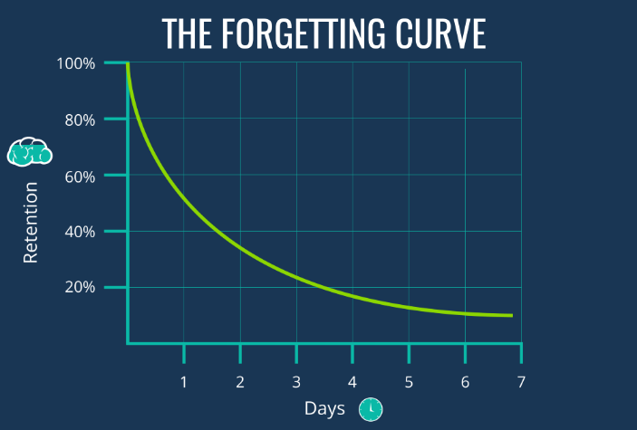
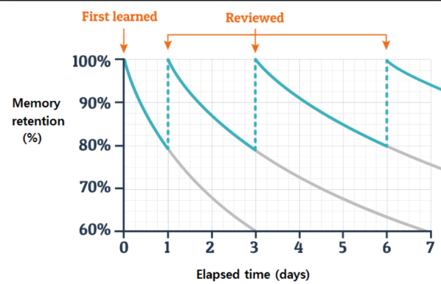

Now back to physics . . .

3: GRAVITY

Something to think about
- Why do two objects with different masses fall at the same rate? After all, we know from Newton’s law that the force between two objects is proportional to the product of their masses, so for example the force between the Earth and a 1 kg mass is 1000 times greater than the force between the Earth and a 1 gram mass.

- Fancy an Earth sandwich? Simply find someone who is on the exact opposite side of the world and arrange for them to put a slice of bread on the ground at the same time as you. I like mine with mustard.

- Imagine there is a hole going from the top of the earth right out the other side. You see this hole and not having any sense worth talking about, decide to jump in. Describe how your weight changes as you fall.



Is gravity real - or does the Earth just suck?
To understand why gravity is so strange, we need to look at it from the perspective of the image on the right. When we think of things ‘falling’ we tend to think of it from the perspective of the first image where it just looks ‘natural’ and therefore there is nothing to wonder about (this goes all the way back to Aristotle). The movement of the apple on the right just doesn’t look right, but it is this image which is the more valuable in terms to trying to understand the force of gravity.
The words we use don’t necessarily help us either. We would say that the apple on the left “falls down”. “Falls” somehow implies that this is the ‘natural’ way to go. How would you describe the motion of the apple on the right?

What is so significant about the apple falling on Newton’s head is that when the apple (allegedly) fell on his head it prompted him to think about it from the perspective of the second image and this caused him to realise that our view up to that point was incorrect.
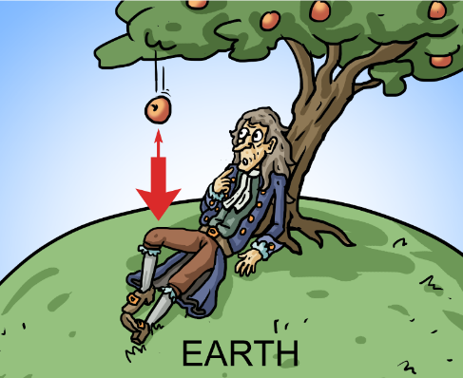
This is how Newton’s friend William Stukeley tells the story:
We went into the garden, & drank thea under the shade of some appletrees, only he, & myself. amidst other discourse, he told me, he was just in the same situation, as when formerly, the notion of gravitation came into his mind. "why should that apple always descend perpendicularly to the ground," thought he to himself: occasion'd by the fall of an apple, as he sat in a comtemplative mood: "why should it not go sideways, or upwards? but constantly to the earths centre? assuredly, the reason is, that the earth draws it. there must be a drawing power in matter. & the sum of the drawing power in the matter of the earth must be in the earths center, not in any side of the earth. therefore dos this apple fall perpendicularly, or toward the center. if matter thus draws matter; it must be in proportion of its quantity. therefore the apple draws the earth, as well as the earth draws the apple."

Student Notes

Newton’s law of gravitation
states that any two point masses in the universe attract each other with a force that is directly proportional to the product of their masses, and inversely proportional to the square of the distance between them.
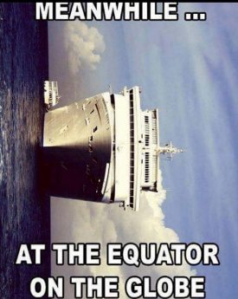
Mathematically: F_{G} ∝ (M₁ M₂) and F ∝$\frac{1}{d^{2}}$

Putting this together

G is known as ‘the universal gravitational constant’ (or ‘big G’ for short) is a constant.
Its value is 6.7 x 10⁻¹¹ N m² kg⁻² (you can find this number in the Formula & Tables book).


It just doesn’t seem right that we take for granted our flimsy attachment to the surface of the planet, and all because of a very mysterious force which few if any of us understand. Were that force to disappear (even momentarily) we would immediately find ourselves projected out into the darkest, coldest and most inhospitable environment imaginable.

A genius is someone who discovers that the stone that falls and the moon that doesn't fall represent the same phenomena.
Ernesto Sábato

Newton’s law of gravitation maths questions
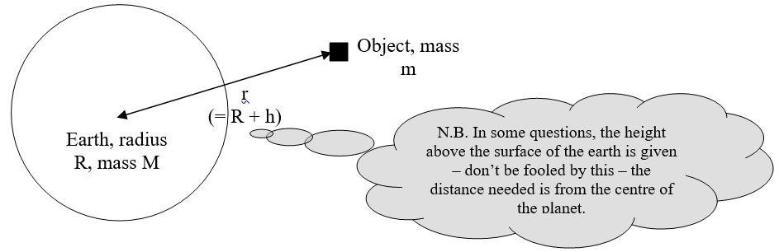

Calculate the gravitational force of attraction between the masses in each question below

Example 1  Mass 1 = 10 kg  Mass 2 = 10 kg  Distance 1 m | $F=G\frac{m_{1}m_{2}}{d^{2}}$ = ${[6.7×10}^{-11}]\frac{(10)(10)}{{(1)}^{2}}$ = 6.7 × 10⁻⁹ N
Example 2  Mass of Earth = 6.0 × 10²⁴ kg  Mass of moon = 7 × 10²² kg  Distance between centre of masses = 3.84 × 10⁸ m | $F=G\frac{m_{1}m_{2}}{d^{2}}$ = ${[6.7×10}^{-11}]\frac{({6.0×20}^{24})({7×10}^{22})}{{({3.84×10}^{8})}^{2}}$  = N
Example 3  Mass of teacher = 75 kg  Mass of earth = 6.0 × 10²⁴ kg  Distance = radius of the earth = 6.36 × 10⁶ m | Force of attraction =  $F=G\frac{m_{1}m_{2}}{d^{2}}$ = ${[6.7×10}^{-11}]\frac{(75)({6.0×20}^{24})}{{({6.36×10}^{6})}^{2}}$  = 6.7 × 10⁻⁹ N
Example 4  Calculate the weight of a man of mass 75 kg.  How does your answer compare to the answer for the question just above this one?  What is the significance of this? | F = W = 75 N

This means that each of us is ‘attracted’ to every one of our colleagues, and the bigger they are, the greater the attraction. It also means that you are more likely to be attracted to your average American than to a person of almost any other nationality on this planet.

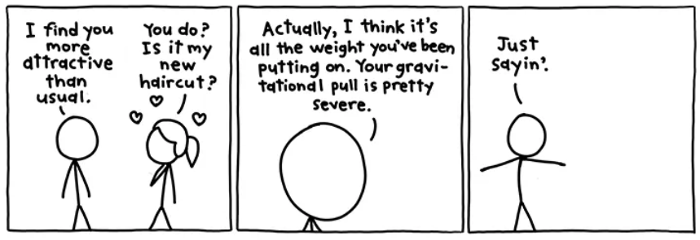

xkcd.com

Gravity and weight
W = mg
We have already that weight and mass are related by the following formula:

Remember that in this context g represents the strength of the gravitational field and it is called the gravitational field strength. The unit of g is the N/kg and the value of g on Earth is taken to be 9.8 N/kg or 9.8 N kg⁻¹.

Remember also that every textbook and exam question in this country refers incorrectly to g in this context as acceleration due to gravity.

The word weight is merely shorthand for force due to gravity so we now have two expressions for this force due to gravity: mg and $\frac{Gm_{1}m_{2}}{d^{2}}$

Let’s set them equal to each other: $\frac{Gm_{1}m_{2}}{d^{2}}$ = mg
Now on the left hand side one of these masses (m₁) represents the mass of the planet and m₂ represents the mass of the second (usually smaller) object, while on the right hand side m represents the mass of this smaller object.
So cancelling this m on both sides leaves us with $g=\frac{GM}{d^{2}}$
$$g=\frac{GM}{d^{2}}$$

- This now allows us to calculate a value for the gravitational field strength (g) at any distance from a given planet.
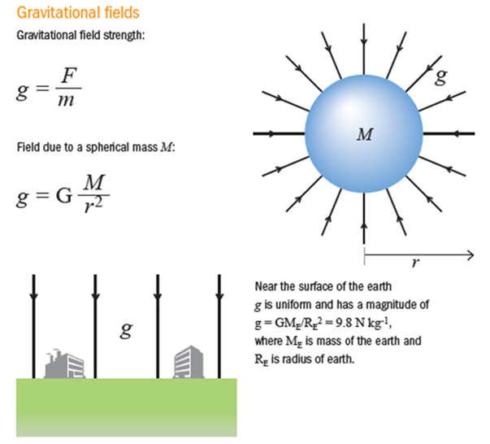
- d represents the distance between the centres of gravity of the two masses.

- The three formulae in this chapter can all be found on page 56 of the Formula & Tables book.

Distinguishing between mass and weight

2008 Question 6 [Ordinary Level]
- Calculate the acceleration due to gravity on the moon.
The radius of the moon is 1.7 × 10⁶ m and the mass of the moon is 7 × 10²² kg.
- A lunar buggy designed to travel on the surface of the moon had a mass of 2000 kg when built on the earth.
What is the weight of the buggy on earth?
- What is the mass of the buggy on the moon?
- What is the weight of the buggy on the moon?
- A powerful rocket is required to leave the surface of the earth.
A less powerful rocket is required to leave the surface of the moon. Explain why.

Part (i)  radius = 1.7 × 10⁶ m  radius of the moon is 1.7 × 10⁶ m | $$g=\frac{GM}{d^{2}}=\frac{{(6.7×10}^{-11})({7×10}^{22})}{{{(1.7×10}^{6})}^{2}}$$  g = 1.6 m s⁻²
Part (ii) | W = mg = 2000 × 9.8 = 19600 N
Part (iii) | 2000 kg
Part (iv) | W = mg = 2000 × 1.6 = 3200 N
Part (v) | The force of gravity is less on moon so less force is needed to overcome the gravitational attraction to the moon

2014 Question 6 [Ordinary Level]
- Calculate, to one decimal place, the acceleration due to gravity on Mars.
The radius of Mars is 3.4 × 10⁶ m and the mass of Mars is 6.4 × 10²³ kg.
- In August 2012 the Curiosity rover landed on Mars.
The wheels of the rover are not as strong as the wheels that would be needed if the rover was to be used on Earth. Give a reason for this.
- The Curiosity rover was built on Earth to travel on the surface of Mars.
The rover has a mass of 899 kg. Calculate the weight of Curiosity on Earth.
- What is the mass of the buggy on the moon?
- What is the weight of the buggy on the moon?

Part (i)  radius of Mars is 3.4 × 10⁶ m  mass of Mars is 6.4 × 10²³ kg. | $$g=\frac{GM}{d^{2}}=\frac{{(6.7×10}^{-11})({6.4×10}^{23})}{{{(3.4×10}^{6})}^{2}}$$  g = 3.7 m s⁻²
Part (ii) | the rover weighs less on Mars // force of gravity is less on Mars // the mass of Mars is smaller than mass of Earth
Part (iii) | W = mg = (899)(9.8) = 8.8 × 10³ N
Part (iv) | 899 (kg) // the same as on Earth
Part (v) | W = mg = (899)(3.7) = 3.3 × 10³ N

Two very different types of mass

Newton, just 50 years after Galileo, developed the idea that gravitational and inertial mass were different concepts. wikipedia

The word ‘mass’ actually means (at least) two very different things in physics
1. Inertial mass
The inertial mass of an object is a measure of the resistance which the object has to a change in its velocity.
We can calculate inertial mass using the formula F = ma or $a=\frac{F}{m}$

2. Gravitational mass
The gravitational mass of an object determines the size of the gravitational attraction between that object and any other object.
We can calculate gravitational mass using the formula $F=G\frac{m_{1}m_{2}}{d^{2}}$

Incredible though it may seem, whenever we take an object and measure its inertial mass and its gravitational mass we end up with the same value which is why we can use the one word ‘mass’ to mean either quantity. And we can also assign it the same unit – the kilogram. To this day physicists continue to come up with different experiments to measure the gravitational and inertial mass of the same object to see if there is a difference in results (google ‘Eötvös experiment’ for more). They haven’t found any yet. It’s also the reason that objects of different mass fall at the same rate. It’s just another wonderful story in physics that we’re not supposed to tell you in case you end up thinking that physics is interesting.

Physics and Chaos
So we can use this to predict the motion of any planet due to the existence of another neighbouring planet. The next challenge was to see if it was possible to come up with an equation which would allow for the motion of a planet due to existence of two other planets.
Scientists quickly realised that this was an incredibly complex problem and was impossible to solve with the maths tools available to them at that time.
It was one of the first examples of what we now call Chaos Theory. The underlying rules were simple but the process rapidly becomes very complex. Scientists have made a lot of progress in this area since the advent of the computer. There is a wonderful documentary (available on YouTube) called ‘The Colours of Infinity’ which explains Chaos Theory much better than I ever could. By the way, Chaos Theory explains why the weather can never be predicted more than 13 days in advance, regardless of what local experts will tell you.

What’s in a word: what is gravity?
The reason apples fall to the ground is because of ‘gravity’.

Yes the term ‘gravity’ is what we use to label the phenomenon, but does tell us anything new?
After all, I’m sure the word preceded Isaac Newton, so why did he feel that there was anything left to explain?
Anytime I mention this in class I am invariably met with a set of puzzled faces, so in an effort to explain further I draw a picture of the Earth, with an apple tree on top and an apple hanging out of it. Now everyone knows that when the apple falls it will fall ‘down’ to Earth. What happens next is very interesting.
Students don’t see that there is anything to explain about why an apple falls to the ground – it’s just the way it’s meant to be (harking back to Aristotelian notions).
Now draw an upside-down apple tree underneath the Earth and have an apple in mid-air. Which way does it fall? An upside-down stick figure might help them appreciate what’s going on. It’s still pretty amazing though. Now complicate things just a little by saying the man has just spilt a cup of tea – what will happen? You may find that our language causes confusion here. Does the apple ‘fall up to the ground’? What does this tell us about the words ‘fall’ and ‘up’?

The apple which ‘falls up’ may now need a little explanation. It’s at this stage that the resident nerd declares confidently ‘That’s easy, gravity pulls the apple to earth’, and unfortunately, as with most nerds, he’s right. But wait. One simple question can now cause the rest of your class plan to go out the window (there’s a moral in there somewhere). “What is gravity”? Now at this stage a series of hands may go up because everyone knows what gravity is; it’s what causes objects to be pulled to Earth. Now it’s time to explain what a tautology is.

But back to the apple.
Hopefully by now those of you still reading this will know where I’m heading. Knowing about the word ‘gravity’ and knowing what gravity is are two rather different concepts.

I personally know very little about what gravity is. I could try to sound impressive throwing out terms like gravitational field, gravitons, superstring theory, relativity, space-time and the like but that would be little better than what I was correcting the students over.

Instead what I prefer to do is to highlight the fact that Newton himself was very uncomfortable with talking about what gravity actually was. What he did was to show mathematically some of rules which govern how gravity works. He came up with a formula which would predict the force of attraction between any two masses, and because everybody thought that Newton was so brilliant they decided to call his formula a Law, which sounds much more impressive. How and why Newton was promoted as one of science’s secular saints is another story worth reading. But not for now.

Which brings us nicely back to the apple. Newton has many claims to fame, but perhaps one of his greatest achievements was acting as a signpost to all other scientists, showing them how science should be carried out. There should be no reference to divine intervention; every claim should be open to verification (or falsification) by experiment. This was why he was so uncomfortable talking about why gravity worked. How did the apple know that the earth was beside it? Somehow this information must have been transferred across the space between them, but did it take time or was it instantaneous?

SLOP
universal gravitational constant (G) = 6.7 x 10⁻¹¹ N m² kg⁻²
Radius of the earth = 6.36 × 10⁶ m Gravitational field strength at the earth’s surface = 9.81 m s⁻²
Distance from the centre of the earth to the centre of the moon = 3.84 × 10⁸ m
Mass of the earth is 6.0 × 10²⁴ kg

State Newton’s law of universal gravitation. | Any two point masses in the universe attract each other with a force that is proportional to the product of their masses, and inversely proportional to the square of the distance between them.
Give two factors which affect the size of the gravitational force between two bodies. | The mass of the objects and the distance between them.
Calculate the weight of a man of mass 75 kg.
How does your answer compare to the answer for the question just above this one?
What is the significance of this?
What is the relationship between gravitational field strength g and the distance from the centre of the earth? | g is proportional to 1/d²
An astronaut in the ISS appears weightless. Explain why. [2008] | He is in a state of free-fall (the force of gravity cannot be felt).
Describe the variation in the weight of the astronauts as they travel to the moon. [2010] | Weight decreases as the astronaut moves away from the earth and gains (a lesser than normal) weight as she/he approaches the moon
Why is the acceleration due to gravity on the moon less than the acceleration due to gravity on the earth? | The earth has a greater mass than the moon.
The earth is covered with a layer of air called the atmosphere.  What holds this layer of air close to the earth? | The gravitational force (if you just say ‘gravity’ you won’t get the marks).
The earth is surrounded by a layer of air, called its atmosphere.  Explain why the moon does not have an atmosphere. | The gravitational force is too weak to sustain an atmosphere.
What type of force is required to keep the ISS in orbit?  What is the direction of this force? | The gravitational force  Towards the centre of the orbit / towards the earth
Calculate the gravitational field strength on the moon.  The radius of the moon is 1.7 × 10⁶ m and the mass of the moon is 7 × 10²² kg. [2008 OL] | 1.6 m s⁻²
Calculate the acceleration due to gravity at a point 400 km above the surface of the earth.  The radius of the earth is 6.4 × 10⁶ m and the mass of the earth is 6.0 × 10²⁴ kg. | g = 8.6 m s⁻²  See Question 6 2008 for full solution
Calculate the gravitational field strength at a height above the surface of the earth, which is twice the radius of the earth. [2010]

At what height above the earth’s surface will the astronauts experience weightlessness?
Assume the mass of the earth is 81 times the mass of the moon. [2010] {Leave this until sixth year}

The moon orbits the earth every 27.3 days. What is its velocity, expressed in metres per second? | $v= \frac{distance travelled}{time}= \frac{2πr}{T}$  $$v= \frac{2{π(3.84 ×10}^{8})}{27.3 ×24 ×60×60}$$  v = 1022.9 m s⁻¹
What speed are you travelling at right now? Justify all assumptions.

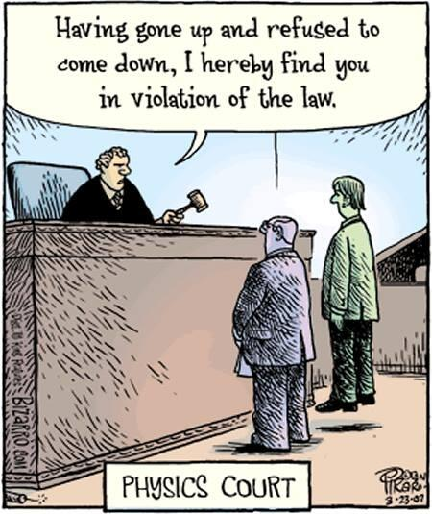
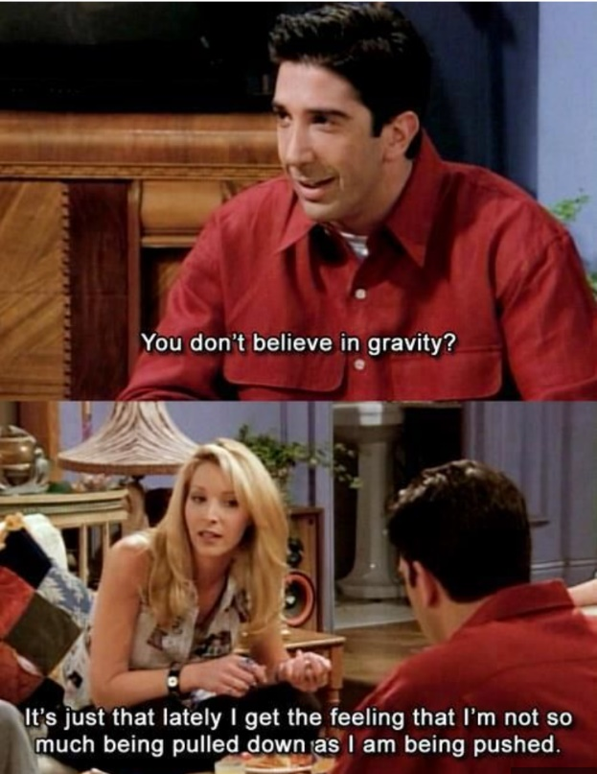
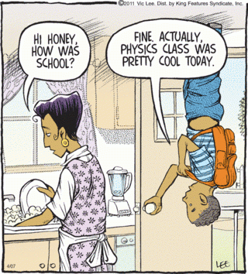

The science of learning quiz: Part 11

- How effective are the following methods of study (in terms of learning information ‘off by heart’)?

Study option | Rating | Explanation
Re-reading your notes
Taking notes
Transcribing
Testing yourself
Highlighting
Copying out answers
Making out flash cards
Making mindmap
Using flash cards
Looking at mindmaps
Copying out notes
Teaching others

- Which is the least efficient study technique and why?
Writing out notes; not only is it not particularly effective, it also takes probably more time than any of the other strategies.

Answers

- How effective are the following methods of study (in terms of learning information ‘off by heart’)?
The following are not absolute but will hopefully give a rough indication of the effectiveness of each.
It is very important that in each case the explanation makes sense; if you don't understand *why* certain techniques work, you won't understand when they should be used and when they shouldn't.

Study option | Rating | Explanation
Re-reading your notes | 3 | This is only really effective if it is followed by some elaborative interrogation techniques (see question 5 above)
Taking notes | 10 | If it involves creating the notes from memory (followed by checking that the notes are correct by comparing them to the textbook).  Why? Because in making out the notes you are recalling (retrieving) the information.
Transcribing | 0 - 3 | I know it’s not what you want to hear, but there it is.
Testing yourself | 10 | This assumes that you’re checking your answers, in which case you then need to take a re-test (and check again)
Highlighting | 0 | It may well be a first step if it is followed by more effective strategies, but there is no learning in the activity itself
Copying out answers | 0 | How much of your homework consists of merely copying out information from a textbook to your copy?)
Making out flash cards | 0 | Save yourself time by downloading these from a website if possible or share with others
Making mindmaps | 10 | Because you have to really think about what you’re doing, and how the various concepts are inter-related, which is a perfect example of an elaborative interrogation technique.
Using flash cards | 10 | You are testing yourself
Looking at mindmaps | 2 | There is no real engagement
Copying out notes | 0 | Again, no real engagement so no effective learning
Teaching others | 10 | Another very good example of elaborative learning

2. Which is the least efficient study technique and why?
Transcribing; not only is it not particularly effective, it also takes probably more time than any of the other strategies.

4: MOMENT OF A FORCE

Student notes

As well as causing an object to accelerate, a force may cause a body to turn or rotate, i.e. a force can have a turning effect.
To quantify this turning effect, we use the following term, called the moment of a force:
Moment of a force = force × perpendicular distance (between the force and the fulcrum)

The unit of moment of a force is the newton metre (N m).
A lever is any rigid object free to turn about a fixed point called a fulcrum.
A fulcrum is the part that the object turns about, like the hinge on a door.
What does the term perpendicular distance mean?

A man opens a door by applying a force of 5 N to the door.  The distance from the point of application of the force to the fulcrum is 120 cm.  Calculate the moment of the applied force. | Force = 5 N  Distance = 120 cm = 1.2 m  Moment of a force = force × distance  = 5 × 1.2  = 6 N m
2017 Question 5 [Ordinary level]  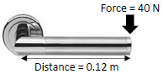  A door handle is used to open a door.  Calculate the moment of the force applied in the diagram. | Force = 40 N  Distance = 0.12 m  Moment of a force = force × distance  = 40 × 0.12  = 4.8 N m
2013 Question 5 [Ordinary level]  The spanner shown in the diagram is used to turn a nut.  Calculate the moment of the force applied by the spanner to the nut. | Force = 50 N  Distance = 0.1 m  Moment of a force = force × distance  = 50 × 0.1  = 5 N m

A couple

Sometimes we will have a situation where we have two parallel forces with the same magnitude acting in opposite directions.
For example, turning a steering wheel (or two people pushing on opposite ends of a revolving door).

We call this a couple. You should too.

Moment of a couple: Torque
The moment of a couple is known as the Torque

Moment of a couple (torque) = force × distance between forces
Torque = force × distance between forces

2003 Question 5 [Ordinary level]  The diagram shows forces of 5 N applied to a water tap.  Calculate the moment of the couple (torque) on the tap. | Solution  Moment = force × distance  = 5 × .06  = 0.3 N m


In engineering terms, the human walk is a process of avoiding falling. You are in a stable (equilibrium) position once your centre of gravity is over your base (the area between your two feet if both are on the ground). As you lift one leg upwards and forwards (technically you are pushing backwards and downwards with your hind foot so the floor pushes you forward and upwards) a number of different concepts come into play. Your base is now just the area under one foot (the one which is still on the ground). Secondly, assuming you are walking, your centre of gravity is no longer over your base - it’s now out in front. This means that you are now no longer in an equilibrium position so you will fall unless you take rapid preventative action. So you put your foot down to prevent you falling over.
Now repeat. It’s quite tricky to get all of this to happen in such a way as to appear ‘normal’ and the brain needs to be functioning normally to coordinate all this.
It’s not surprising that one of the first signs of cognitive difficulty is when someone is no longer walking properly.

Two laws of equilibrium
If an object is in equilibrium then:
- The vector sum of the forces in any direction is zero.
This is like saying that the net force must be zero.

- The sum of the moments about any point is zero
(The sum of the clockwise moments equals the sum of the anti-clockwise moments).
Worked example
A metre stick is suspended by a thread at the 20 cm mark as shown in the diagram. The weight W of the metre stick acts through the 50 cm mark.

- Identify the clockwise and the anti-clockwise moments in the diagram.
- Calculate the moment of the 2 N weight about the 20 cm mark.
- Calculate the moment of W about the 20 cm mark. Give your answer in terms of W.
- If the metre stick is in equilibrium, find the value of W.

Solution
- Identify the clockwise and the anti-clockwise moments in the diagram.
It’s not always obvious which force is associated with the clockwise or anti-clockwise moment. A useful way to consider it is to ask yourself the following: if the metre stick was pinned to the wall and there was no other force acting on it other then the force in question, would the metre stick turn clockwise or anti-clockwise. If it turns clockwise then the moment of the force is clockwise and if it turns anti-clockwise then the moment of the force is anti-clockwise.
So in this case the clockwise moment is associated with the weight W and the anti-clockwise moment is associated with the 2 N force.

- Calculate the moment of the 2 N weight about the 20 cm mark.
Reminder that the formula for the moment of a force is:
Moment of a force = force × distance (between the force and the fulcrum).
The part in brackets is important because the most common mistake here is to use 15 cm as the distance, whereas the correct distance is 5 cm (or 0.05 m) because that’s the distance between the force of 2 N (which is at the 15 cm mark) and the fulcrum (which is at the 20 cm mark).
The moment associated with the 2 N force is therefore: M = force × distance = 2 × 0.05 = 0.1 N m

- Calculate the moment of W about the 20 cm mark. Give your answer in terms of W.
The distance in this case is 30 cm (0.3 m) because it’s the distance between the weight W (which is at the 50 cm mark) and the fulcrum (which is at the 20 cm mark).
The moment associated with the weight W is therefore: M = force × distance = W × 0.3 m = 0.3W N m

- If the metre stick is in equilibrium, find the value of W.
Here we use the second law of equilibrium: the sum of the clockwise moments equals the sum of the anti-clockwise moments. In this case we only have one clockwise moment and one anti-clockwise moment so we can just set them equal to each other to find the unknown weight W.
Clockwise moments = anti-clockwise moment
0.3W = 0.1 Therefore W = 0.33 N

If there are two or more forces on one side of the fulcrum then you will need to add the moments of these forces together to get the sum of the moments on that side. See below.

Remember that the distance in each case is the distance between the force and the fulcrum; this is often -but not necessarily -at the 50 cm mark

Note that for many of the questions below we keep distances in cm. Why?
Because we will be using an equation (sum of clockwise moments = sum of anticlockwise moments) so once we have the same units on both sides the job is oxo.

If you are asked to find the moment of the force you can keep the distance in cm, in which case you must give the unit as N cm, or convert to metres in which case the unit is N m. This logic applies for all exam questions unless you are specifically told otherwise.

What is the moment of the 9000 N concrete slab about the axis of the crane?  Calculate the value of the load marked X. | clockwise moments = anticlockwise moments  (9000)(10) = (X)(30)  X = 3000 N
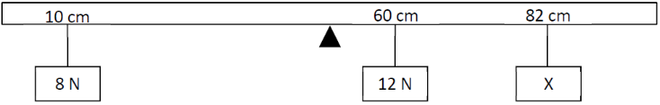  2018 HL Question 5  A horizontal metre stick is in equilibrium when a weight of 8 N hangs from the 10 cm mark, a weight of 12 N hangs from the 60 cm mark and an unknown weight (X) hangs from the 82 cm mark.  The metre stick is supported at its centre of gravity which is at the 50 cm mark.  Calculate X. | The anticlockwise moment is due to the 8 N force.  Moment of anticlockwise force = (8)(40)  The clockwise moments are due to the 12 N and X N forces.  Moment of clockwise forces = (12)(10) + (X)(32)  clockwise moments = anticlockwise moment  (12)(10) + (X)(32) = (8)(40)  X = 6.25 N

What is meant by the centre of gravity of an object?
The centre of gravity is the point of a body where all its weight appears to act.

To find the centre of gravity of a metre stick we could hang the metre stick from a piece of thread and adjust the position of the thread until the metre stick is in equilibrium (no longer rotates).

2022 Question 14 (c) [Ordinary Level]
The diagram shows a metre stick which is suspended from its mid‐point (50 cm) with three masses hanging from it. The metre stick is in equilibrium.
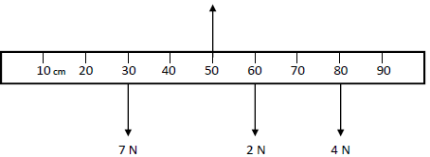

- Calculate the total clockwise moment about the midpoint of the metre stick.
- Calculate the total anticlockwise moment about the midpoint of the metre stick.
- State the law of equilibrium verified by the calculations in (i) and (ii).
- The upward force on the metre stick is 15 N. Calculate the weight of the metre stick.

Part (i) | (2 × 10) + (4 × 30) = 140 N cm
Part (ii) | 7 × 20 = 140 N cm
Part (iii)
These calculations verify the second law of equilibrium: T
The sum of the clockwise moments = The sum of the anti-clockwise moments

Part (iv)
The weight of the metre stick isn’t shown on the diagram, but if it was it would be acting downwards so we can use:
Total force upwards = 15 N {we are told this in the question]
Total force downwards = (7 + 2 + 4 + W) N

Total force upwards = total force downwards
15 = (7 + 2 + 4 + W)

W = 2 N

INVESTIGATION OF THE LAWS OF EQUILIBRIUM FOR A SET OF CO-PLANAR FORCES

APPARATUS Two newton-meters, metre-stick, weights, paperclips, spirit-level, electronic balance

DIAGRAM

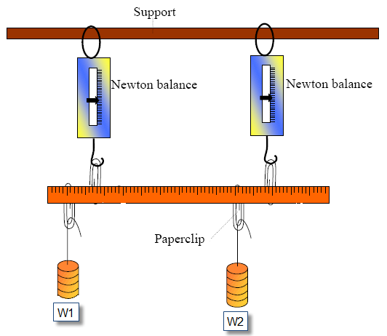

PROCEDURE
- Find and note the centre of gravity of the metre-stick by hanging it from a thread and adjusting the position of the thread such that the metre-stick is horizontal.
- Find and note the mass of the metre-stick by weighing it on an electronic-balance.
- Set up the apparatus as shown and move the weights around until the stick is horizontal and in equilibrium (not rotating). The newton-metres must be vertical.
- Record the reading on each newton-metre and the positions on the metre stick of each weight, each newton-metre and the values of the weights themselves.

RESULTS (this information could also be represented on a diagram)

position on metre stick/cm

magnitude of force/N

direction of force

CALCULATIONS
FIRST LAW: TOTAL FORCES UP = TOTAL FORCES DOWN

SECOND LAW: TOTAL MOMENTS CLOCKWISE = TOTAL MOMENTS ANTI-CLOCKWISE

CONCLUSION
We can see from our results that we were able to verify both laws within the margins of experimental error.

SOURCES OF ERROR / PRECAUTIONS
- Ensure that the newton balances are vertical and the metre stick is horizontal when readings are taken.
- Avoid parallax error when reading the lengths and forces.
- Use large weights (i.e. multiples of 1N) to reduce percentage errors.

Theory questions

Draw a diagram of the experimental arrangement that the student used.

Copy the diagram and show all the forces acting on the metre stick. | Include all forces as indicated above but don’t forget to include the weight acting downwards from the centre of gravity.
Use the data given to calculate the net force acting on the metre stick | Net force corresponds to forces up minus force downs which should be approximately zero.
Explain how these values verify one of the laws of equilibrium. | The vector sum of the forces acting vertically is zero.
Explain how these values verify the other law of equilibrium. | Sum of the moments clockwise equals sum of the moments anticlockwise.
How did the student find the weight, of the metre stick? | By weighing it on an electronic set to measure newtons.
Give one possible reason why the centre of gravity is not at the 50.0 cm mark. | Metre stick not uniform / stick chipped / extra material on one end
Describe how the centre of gravity of the metre stick was found. | Balanced the metre stick horizontally on a string and adjust the position until the metre stick balances.  Note the position.
Why was it important to have the spring balances hanging vertically? | Moment of a force = force × perpendicular distance, so if the readings on the metre stick are to correspond to these perpendicular distances then the metre stick must be perpendicular to the spring balances, and if the metre stick is horizontal then the spring balances should be vertical.
How did the student know that the metre stick was in equilibrium? | There was no movement.
Explain how the upward forces and downward forces were determined. | By using a newton-meter

Related Exam Questions

HL: 2016, 2013, 2007, 2002 OL: 2014, 2007
[2014 OL]
A student investigated the laws of equilibrium for a set of co-planar forces acting on a metre stick.
The weight of the metre stick was 1.5 N and its centre of gravity was at the 50 cm mark.
The student applied the forces shown to the metre stick until it was in equilibrium.

- How did the student measure the upward forces?
- Copy the diagram and show all the forces acting on the metre stick.
- Find the total upward force acting on the metre stick.
- Find the total downward force acting on the metre stick.
- Explain how these values verify one of the laws of equilibrium.
- Find the sum of the anticlockwise moments of the upward forces about the 0 mark.
- Find the sum of the clockwise moments of the downward forces about the 0 mark.
- Explain how these values verify the other law of equilibrium.

[2016 HL]
In an experiment to verify the laws of equilibrium, the centre of gravity and the weight of a metre stick were found.
The centre of gravity of the stick was at the 50.2 cm mark and its weight was 1.1 N.
- Explain how the centre of gravity was found
- Explain how the weight of the metre stick was found
- Explain how the upward forces and downward forces were determined.
- Give one possible reason why the centre of gravity is not at the 50.0 cm mark.
- Use the data given to calculate the net force acting on the metre stick
- Use the data given to calculate the sum of the moments about the 40 cm mark of the metre stick.
- Explain how your calculations verify the laws of equilibrium.

[2007 HL]
A student investigated the laws of equilibrium for a set of co-planar forces acting on a metre stick.
position on metre stick/cm | 11.5 | 26.2 | 38.3 | 70.4 | 80.2
magnitude of force/N | 2.0 | 4.5 | 3.0 | 5.7 | 4.0
direction of force | down | up | down | up | down
The student found that the centre of gravity of the metre stick was at the 50.4 cm mark and its weight was 1.2 N.

- How did the student find the centre of gravity?
- How did the student find the weight, of the metre stick?
- Why is the centre of gravity of the metre stick not at the 50.0 cm mark?
- The student applied vertical forces to the metre stick and adjusted them until the metre stick was in equilibrium. How did the student know that the metre stick was in equilibrium?
The student recorded the following data.
- Calculate the net force acting on the metre stick.
- Calculate the total clockwise moment about a vertical axis of the metre stick.
- Calculate the total anti-clockwise moment about a vertical axis of the metre stick.
- Use these results to verify the laws of equilibrium
Solutions to maths parts

[2014 OL]
- Find the total upward force acting on the metre stick.
9 + 12.5 = 21.5 N
- Find the total downward force acting on the metre stick.
5 + 15 + 1.5 = 21.5 N
- Find the sum of the anticlockwise moments of the upward forces about the 0 mark.
(9)(0.2) + (12.5)(0.9) = 1.8 + 11.25 = 13.05 N m
- Find the sum of the clockwise moments of the downward forces about the 0 mark.
(5)(0.36) + (1.5)(0.5) + (0.7)(15) = 1.8 + 0.75 + 10.5 = 13.05 N m

[2016]
- Use the data given to calculate the net force acting on the metre stick
Upward force = 3.9 + 4.1 = 8.0 N Downward force = 2 + 3 + 2 + 1.1 = 8.1 N
Net vertical force = 0.1 N // upward ≈ downward
- Use the data given to calculate the sum of the moments about the 40 cm mark of the metre stick.
Moment = force × displacement
Clockwise moments = (2 × 0.52) + (1.1 × 0.102) + (3.9 × 0.04) = 1.3082 N m
Anti-clockwise moments = (2 × 0.24) + (4.1 × 0.20) = 1.3 N m
Sum of moments ≈ 0 N m // clockwise ≈ anti-clockwise

[2007]
- Calculate the net force acting on the metre stick.
F_{up} = 4.5 + 5.7 = 10.2 N and F_{down} = 2 + 3 +1.2 +4 = 10.2 N So net force = 0
- Calculate the total clockwise moment about a vertical axis of the metre stick.
(through zero) = 2(0.115) + 3(0.383) +1.2(0.504) +4.0(0.802) = 0.23+1.149+0.6048+3.208 = 5.2 N m
- Calculate the total anti-clockwise moment about a vertical axis of the metre stick.
(through zero) = 4.5(0.262) +5.7(0.704) = 5.1918 N m = 5.2 N

Notes to the experiment

Why do we have to ensure that all forces are vertical?
Because the moment of a force is defined as being equal to the force multiplied by the perpendicular distance between the force and the fulcrum. So if we’re going to use the numbers on the meter stick as our perpendicular distance we better make sure that that the metre stick is perpendicular to the forces in the first place. The best way to do this is ensure that the forces are vertical and the metre stick is horizontal.

Do we have to use the extreme left hand side as our reference point?
When calculating the moments, we generally use the 0 cm mark as our fulcrum, and measure all distances from this point. Strictly speaking we could take any point on the metre stick as our reference point (or fulcrum) but the 0 cm mark is the easiest.
You should be able to work out the calculations about other points (in the 2002 exam students were asked to calculate the moments about the 10 cm mark). Apart from all distances now being calculated from the 10 cm mark, the other change could be that some forces which exerted a clockwise moment about the 0 cm mark may now exert an anti-clockwise moment about the 10 cm mark.
Some of the exam questions ask you to calculate moments about various positions on the same metre-stick; it’s good practice and re-enforces the concept that the actual position of the fulcrum doesn’t matter in these situations.

Watch out!
Setting up the apparatus can be time-consuming and the whole set-up can be rather precarious, so you might want to consider the following advice:
As soon as you have everything set-up and balanced, sketch a diagram of it and indicate on it the position and force of each object.
This should be done as quickly as possible while the apparatus is still stable before some nutter bangs against it and brings it all crashing down.
Then the tears will start.
Once you have all the relevant readings you should fill in the table and work out the calculations – that way if your results are way off you can double-check them without setting everything up again.
You have been warned!

Use large weights
Not only will the large weights reduce the percentage errors associated with the weights themselves, they will also help to mask errors associated with the various forces not being horizontal and vertical.

If you are feeling adventurous you could try three or four weights acting down, rather than just two.

SLOP

Define the moment of a force. | Moment of a force = the force × perpendicular distance between the force and the fulcrum.
Why is it easier to turn a nut using a longer spanner than a shorter one? | The distance from the fulcrum is greater therefore there is a greater turning effect.
Explain why the handle on a door is on the opposite side to the hinges of the door. | In order to maximise the distance between the force and the fulcrum which in turn maximises the turning effect.
A crane is an example of a lever.  Give another example of a lever. | Crowbar / nailbar / nutcracker / wheelbarrow / tongs / door handle etc.
What are the two conditions for the equilibrium of a set of co-planar forces? | Forces up = forces down // (algebraic) sum of forces acting is zero  Total clockwise moments about any point equals total anti-clockwise moments about any point.

The science of learning quiz: Part 12

- List three things to be wary of when using highlighting as a study technique.

- What is the typical time for which a student can concentrate?

- What’s the significance of this in relation to your own study?

- Memory can be divided into two categories – what are they?

- Why is ‘cramming’ not recommended as a learning strategy?

- Quite often we do know the material the night before the test yet still end up doing poorly.
What’s going on?

Answers

- List three things to be wary of when using highlighting as a study technique.
- There is no actual learning taking place (unless it gets followed by an effective study technique).
- Highlighting can lead to illusions of competence where you conflate recognising the information with understanding
- We usually highlight when we first encounter the material, but this is also the stage where we are least likely to know which bits are important (unless the teacher is telling you to highlight it, or if it’s in bold). What happens to the parts of the text which don’t get highlighted?

- What is the typical time for which a student can concentrate?
About 10 – 15 minutes. This can be extended through practice. ‘Top’ students, particularly in college, can stretch this out to a few hours at a time, but this is the exception rather than the rule.
YouTube video from a psychology professor. It’s one hour long so just look at the first 5 minutes.

- What’s the significance of this in relation to your own study?
You need to take a lot of (relatively short) breaks rather than studying for a solid hour or more.

- Memory can be divided into two categories – what are they?
Short-term and long-term memory

- Why is ‘cramming’ not recommended as a learning strategy?
Depending on the study technique you use, information will either only be held in short term memory (where is only stored for approximate 20 to 30 seconds), or in long term memory. If it’s in long term memory it may last long enough for you to pass or even do well in your exam, but it won’t last much longer than that. So learning the information in a one-off fashion may be fine if your aim is to do well for an exam the following day, but because there is no ongoing retrieval involved (apart from regurgitating the material in the test itself) little if any of the material is likely to be stored in long term memory for any meaningful period of time afterward.

- Quite often we do know the material the night before the test yet still end up doing poorly.
What’s going on?
The student has confused familiarity with the material with effective learning. You may have read over the material and even understood it, and this then leads to the illusion of learning. You have not engaged in any ongoing retrieval activities so the information is not securely stored in long term memory. The only way around this is to engage in elaborative learning techniques well in advance of the day of the test.

Here’s another example of the same phenomenon. You watch a teacher solve a maths problem line by line on the board. The teacher explains it well as he goes along so by the end you are pretty sure you understand it, but then if the teacher asks you to do it yourself you find yourself getting stuck very quickly. Why are you surprised by this – are you able to remember all the words to a song the first time you hear it just because you understand all the words?

MECHANICS II EXAM QUESTIONS 2002 – 2023

Work, energy and power: Ordinary level

2020 Question 6 [Ordinary Level]
Sir Isaac Newton was an English mathematician and physicist.
He is widely recognised as one of the most influential scientists of all time.
Newton’s first law of motion states that a body remains at rest or moving at a constant velocity unless an unbalanced external force acts on it.
- A block weighs 400 N. A crane lifts the block so that it moves upwards with constant velocity.
Use Newton’s first law of motion to find the force that the crane puts on the block.

Newton’s second law of motion states that the force on an object is proportional to its rate of change of momentum.
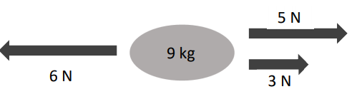
- Calculate the resultant (net) force on the 9 kg object in the diagram above.
- In what direction does it act?
- Calculate the acceleration of the 9 kg object.
- State Newton’s third law of motion.
- Use Newton’s third law to explain how a rocket takes off. (A labelled diagram may help your answer.)

A car of mass 700 kg is at rest.
It accelerates at a constant rate for 6 seconds until it is travelling at a velocity of 18 m s^{–1}.
- Calculate the kinetic energy of the car when it is travelling at 18 m s^{–1}.
- Calculate the acceleration of the car.
- Calculate the net force on the car as it accelerates.

The engine of the car provides a driving force of 3000 N.
(ix) Calculate the friction acting on the car.
(x) State one method of reducing friction.

2005 Question 11 [Ordinary Level]
Read the following passage and answer the accompanying questions.
There are different forms of energy. Fuels such as coal, oil and wood contain chemical energy. When these fuels are burnt, the chemical energy changes into heat and light energy. Electricity is the most important form of energy in the industrialised world, because it can be transported over long distances via cables. It is produced by converting the chemical energy from coal, oil or natural gas in power stations.
In a hydroelectric power station the potential energy of a height of water is released as the water flows through a turbine, generating electricity.
Energy sources fall into two broad groups: renewable and non-renewable. Renewable energy sources are those which replenish themselves naturally and will always be available – hydroelectric power, solar energy, wind and wave power, tidal energy and geothermal energy. Non-renewable energy sources are those of which there are limited supplies and once used are gone forever. These include coal, oil, natural gas and uranium.
(Adapted from the Hutchinson Encyclopaedia of Science, 1998).
(a) Define energy.
(b) What energy conversion takes place when a fuel is burnt?
(c) Name one method of producing electricity.
(d) Give one factor on which the potential energy of a body depends.
(e) What type of energy is associated with wind, waves and moving water?
(f) Give one disadvantage of non-renewable energy sources.
(g) How does the sun produce heat and light?
(h) In Einstein’s equation E = mc², what does c represent?

2011 Question 6 [Ordinary Level]
- State Newton’s first law of motion.
- A car of mass 1400 kg was travelling with a constant speed of 15 m s⁻¹ when it struck a tree and came to a complete stop in 0.4 s.
Draw a diagram of the forces acting on the car before it hit the tree.
- Calculate the acceleration of the car during the collision.
- Calculate the kinetic energy of the moving car before it struck the tree.
- What happened to the kinetic energy of the moving car?
- A back seat passenger could injure other occupants during a collision.
Explain, with reference to Newton’s laws of motion, how this could occur.
- How is this risk of injury minimised?

2016 Question 12 (a) [Ordinary Level]
- Define kinetic energy and potential energy.
- Students carried out an experiment to investigate how to protect a falling egg from breaking.
They observed the results when an egg of mass 52 g was dropped from a height of 2 m, when protected and unprotected.
Calculate the potential energy of the egg before it was dropped.
- Calculate the velocity of the egg as it hit the ground.
- Suggest how the egg could be protected from breaking when it hits the ground.
- State one everyday application of the principal behind the protection of the egg.
(acceleration due to gravity, g = 9.8 m s^{‒2})

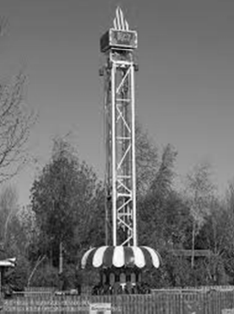
2023 Question 7 [Ordinary level]
A big drop is an amusement ride where a carriage with passengers is lifted to the top of a large vertical tower and then released to fall down the tower before it brakes and comes to rest.
- As the carriage travels to the top, the carriage is gaining potential energy. What is meant by potential energy?
- Draw a diagram of the forces acting on the carriage as it travels up the tower at a constant velocity.
- The carriage is dropped from a height of 37 m above the braking zone. The mass of the carriage is 6200 kg.
- Calculate the potential energy the carriage had before it was dropped.
- What is the main energy conversion that takes place as the carriage falls?
- Calculate the velocity of the carriage when it has fallen 37 m.
- Calculate the time it takes the carriage to fall 37 m.
- Draw a diagram of the forces acting on the carriage as it falls.
- Draw a velocity-time graph for the motion of the carriage from when it was dropped to when it comes to rest.
acceleration due to gravity = 9.8 m s^{–2}

2009 Question 6 [Ordinary Level]
- Define velocity.
- Define friction.
- The diagram shows the forces acting on a train which was travelling horizontally.
A train of mass 30000 kg started from a station and accelerated at 0.5 m s⁻² to reach its top speed of 50 m s⁻¹ and maintained this speed for 90 minutes.
As the train approached the next station the driver applied the brakes uniformly to bring the train to a stop in a distance of 500 m.
Calculate how long it took the train to reach its top speed.
- Calculate how far it travelled at its top speed.
- Calculate the acceleration experienced by the train when the brakes were applied.
- What was the force acting on the train when the brakes were applied?
- Calculate the kinetic energy lost by the train in stopping.
- What happened to the kinetic energy lost by the train?
- Name the force A and the force B acting on the train, as shown in the diagram.
- Describe the motion of the train when the force A is equal to the force T.
- Sketch a velocity-time graph of the train’s journey.

2007 Question 6 [Ordinary Level]
- Define work and give the unit of measurement.
- Define power and give the unit of measurement.
- What is the difference between potential energy and kinetic energy?
- An empty lift has a weight of 7200 N and is powered by an electric motor.
The lift takes a person up 25 m in 40 seconds.
The person weighs 800 N.
Calculate the total weight raised by the lift’s motor.
- Calculate the work done by the lift’s motor.
- Calculate the power output of the motor.
- Calculate the energy gained by the person in taking the lift.
- If instead the person climbed the stairs to the same height in 2 minutes, calculate the power generated by the person in climbing the stairs.
- Give two disadvantages of using a lift.

2015 Question 6 [Ordinary Level]
- Define potential energy.
- Define kinetic energy.
- State the principle of conservation of energy.
- Explain how the principle applies to a roller-coaster.

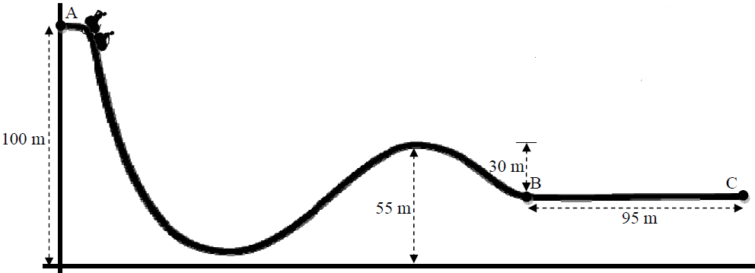
A roller-coaster car of mass 850 kg is released from rest at point A of the track, as shown in the diagram.

- Calculate the difference in height between point A and point B.
- Calculate the change in the potential energy of the car between A and B.
- Write down the kinetic energy of the car at point B, assuming there is no friction and no air resistance.
- Calculate its velocity at point B.
- The brakes are applied at point B and the car comes to a stop at point C.
Calculate the deceleration of the car between B and C.
- Calculate the average force required to bring the car to a stop.
(acceleration due to gravity, g = 9.8 m s⁻²)

2017 Question 6 [Ordinary Level]
A fairground sling-shot is shown below. Springs attached to the pod are used to store a form of potential energy.
When the pod and springs are released, this potential energy is used to exert a force which gives the pod an upward acceleration. At the pod’s highest point, the occupants experience apparent weightlessness for a short time, before gravity causes the pod to fall back towards the ground.

- Explain the underlined terms.
- What form of energy does the pod have due to its motion?
- What form of energy does the pod have at its highest point?
- Why do the occupants experience apparent weightlessness at the pod’s highest point?

The mass of the pod is 400 kg.
It reaches a maximum height of 50 m above its point of release.
- Calculate the potential energy stored in the springs before the pod is released.
- Draw a diagram to show the forces acting on the pod when it is released.
- Calculate the momentum of the pod when it has a speed of 8 m s^{‒1}.
- State one energy loss that might prevent the pod from reaching its maximum height.
(acceleration due to gravity, g = 9.8 m s^{‒2})

2022 Question 14 (a) [Ordinary Level]
A boy picks up a stone of mass 5 g and throws it vertically upwards with an initial velocity of 15 m s^{–1}.
As the stone travels upwards, it loses kinetic energy.
- What is meant by kinetic energy?
- State the principle of conservation of energy.
- What is the main type of energy that the stone’s kinetic energy is being converted into as it travels upwards?
- Calculate the kinetic energy of the stone when it is thrown.
- Calculate the maximum height reached by the stone.
- What is the unit of energy?
(acceleration due to gravity = 9.8 m s^{–2})

2020 Question 11 [Ordinary Level]
Read the following passage and answer the questions below.
WHAT ARE GREENHOUSE GASES?
A wide range of gases contribute to climate change. These are known as greenhouse gases. The most important greenhouse gases are carbon dioxide (CO2), methane (CH4), and nitrous oxide (N2O). These gases contribute to the greenhouse effect by absorbing infrared radiation.
The impact of greenhouse gas emissions on climate disruption must be addressed.
Ireland has experienced the extreme weather events of flooding, drought, and heavy snow.
However, many countries have experienced much worse. Climate change is bringing about desertification, rising sea levels, displaced populations, and severe challenges to the natural world.
These have contributed to significant economic and social disruption. We are close to a tipping point where these crises will get much worse.
Decarbonisation is now a must if the world is to contain the damage and build resilience in the face of this challenge.
Agenda 2030 and the Paris Agreement on climate change require a transformational shift in our economies and societies towards sustainable development. Ireland and the international community are responding to this requirement, setting out a profound change in the practices which support our lifestyle. Every home, community, and workplace must be mobilised to get involved.
Ireland’s climate change plan contains important measures to make Ireland’s development more climate friendly, including achieving the following by 2030:
• A target of 55% renewable power, i.e. from a source that does not get depleted.
• Retrofit plans for 450,000 homes with insulation to a Building Energy Rating (BER) of B2.
• At least half a million electric vehicles on the road, with additional charging infrastructure.
Adapted from dccae.gov.ie
- Name two greenhouse gases that are contributing to climate change.
- State one of the impacts of climate change that Ireland has experienced.
- An electric car uses a battery to make the car move. What energy conversion takes place when this happens?
- What is renewable power?
- What is the SI unit of power?
- The BER rating of a home is dependent on the U‐value of the materials used.
- What is meant by U‐value?
- Wind energy is a significant source of renewable power in Ireland. A wind turbine generates 90 MJ of energy in 60 seconds. Calculate the power of the turbine.
- Other than wind energy, name two other sources of renewable power used in Irish homes.

Questions involving momentum: Ordinary level

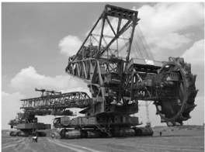
2021 Question 7 [Ordinary Level]
The Bagger 293 excavator is the world’s largest land vehicle, with a mass of 14200 tonnes. (1 tonne = 1000 kg)
Bagger 293 has a maximum speed of 0.17 m s⁻¹.
Bagger 293 has a large momentum.

- What is meant by momentum?
- State the principle of conservation of momentum.
- Explain why Newton’s second law of motion is consistent with the principle of conservation of momentum.
- Calculate the momentum of Bagger 293 when it is moving at its maximum speed.
- Bagger 293 is moving when it picks up a stationary load of 2700 tonnes.
Would this cause its speed to increase or to decrease?
Explain your answer.

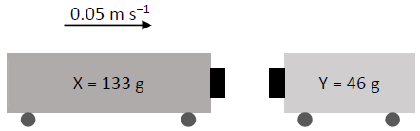
Toy train X has a mass of 133 g and is moving along a track at a velocity of 0.05 m s⁻¹ to the right.
It collides with toy train Y of mass 46 g which is at rest.
The two trains stick together and move down the track together.
- Calculate the initial momentum of train X.
- Calculate the speed of the two trains immediately after the collision.
- In which direction do the two trains move after the collision?
- Calculate the loss in kinetic energy during this collision.
- What happened to the kinetic energy that was lost in the collision?

2012 Question 12 (a) [Ordinary Level]
- State the principle of conservation of momentum.
- A cannon of mass 1500 kg containing a cannonball of mass 80 kg was at rest on a horizontal surface as shown.
The cannonball was fired from the cannon with an initial horizontal velocity of 60 m s^{–1} and the cannon recoiled.
Calculate the recoil velocity of the cannon
- Calculate the kinetic energy of the cannon as it recoils.
- Why did the cannon recoil?
- Why will the cannon come to a stop in a shorter distance that the cannonball?

2018 Question 6 [Ordinary Level]
- Define momentum.
- Define kinetic energy.
- The cannon recoils when a cannon ball is shot from it.
Use the principle of conservation of momentum to explain why the cannon recoils.

Bumper car A of mass 500 kg is moving with a speed of 6 m s⁻¹ when it collides with stationary bumper car B of mass 300 kg.
After the collision the cars move together.

- Calculate the momentum of each car before the collision.
- What is the momentum of the combined cars after the collision?
- Calculate the speed of the two cars after the collision.
- Calculate the kinetic energy of each car before the collision.
- Calculate the kinetic energy of the cars after the collision.
- What conclusion can be drawn from the change in kinetic energy that happens during the collision?

2010 Question 6 [Ordinary Level]
- Define momentum
- Define kinetic energy
- State the principle of conservation of momentum.
- Explain how this principle applies in launching a spacecraft.
- An ice skater of mass 50 kg was moving with a speed of 6 m s⁻¹ then she collides with another skater of mass 70 kg who was standing still. The two skaters then moved off together.
Calculate the momentum of each skater before the collision?
- What is the momentum of the combined skaters after the collision?
- Calculate the speed of the two skaters after the collision.
- Calculate the kinetic energy of each skater before the collision.
- Calculate the kinetic energy of the pair of skaters after the collision.
- Comment on the total kinetic energy values before and after the collision.

Work, energy and power: Higher level

2015 Question 12 (a) [Higher Level]
- State Newton’s second law of motion.
- A downhill skier of mass 71 kg started from rest and travelled a distance of 400 m on a downhill ski course.
Her loss of elevation was 90 m.
What is the principal energy conversion that is taking place as the skier travels along the course?
- Ignoring friction, calculate her maximum velocity when she has travelled 400 m.
- She then ploughed into a snow drift and came to a stop in a time of 0.8 seconds.
What is the force that she exerts on the snow drift?
- What force does the snow drift exert on her?
(acceleration due to gravity = 9.8 m s^{–2})

2008 Question 12 (a) [Higher Level]
- State the principle of conservation of energy.
- In a pole-vaulting competition an athlete, whose centre of gravity is 1.1 m above the ground, sprints from rest and reaches a maximum velocity of 9.2 ms^{–1} after 3.0 seconds.
He maintains this velocity for 2.0 seconds before jumping.
Draw a velocity-time graph to illustrate the athlete’s horizontal motion.
- Use your graph to calculate the distance travelled by the athlete before jumping.
- What is the maximum height above the ground that the athlete can raise his centre of gravity?

2005 Question 12 (a) [Higher Level]
- State the principle of conservation of energy.
- A basketball of mass 600 g which was resting on a hoop falls to the ground 3.05 m below.
What is the maximum kinetic energy of the ball as it falls?
- On bouncing from the ground the ball loses 6 joules of energy.
What happens to the energy lost by the ball?
- Calculate the height of the first bounce of the ball.

2018 Question 6 (c) [Higher Level]
During the pole vault event, Ashton has a horizontal speed of 9.2 m s^{–1} just before he jumps. He converts most of his kinetic energy into elastic potential energy in the pole and then into gravitational potential energy. At his maximum height he has a horizontal speed of 1.1 m s^{–1}.
- State the principle of conservation of energy.
- What is meant by the centre of gravity of a body?
- Ashton’s centre of gravity when he is standing is 98 cm above the ground. During the vault, what is the maximum height above the ground to which he can raise his centre of gravity?
- Draw a diagram to show any forces acting on Ashton when he is at his highest point, as shown in the photograph.
(acceleration due to gravity = 9.8 m s^{–2})

2004 Question 6 [Higher Level]
- Define force.
- Define momentum.
- State Newton’s second law of motion.
- Hence, establish the relationship: force = mass × acceleration.
A pendulum bob of mass 10 g was raised to a height of 20 cm and allowed to swing so that it collided with a block of mass 8.0 g at rest on a bench, as shown.
The bob stopped on impact and the block subsequently moved along the bench.
- Calculate the velocity of the bob just before the collision.
- Calculate the velocity of the block immediately after the collision.
- The block moved 2.0 m along the bench before stopping.
What was the average horizontal force exerted on the block while travelling this distance?
(acceleration due to gravity = 9.8 m s^{–2})

2013 Question 12 (a) [Higher Level]
- State the law of conservation of energy.
- The pendulum in the diagram is 8 m long with a small bob of mass 6 kg at its end. It is displaced through an angle of 30° from the vertical (position A) and is then held in position B, as shown.
Calculate the height through which the bob has been raised and the potential energy that it has gained.
- The bob is then released and allowed to swing freely.
What is the maximum velocity it attains?
- When the moving bob is at position A, a force is applied which brings the bob to a stop in a distance of 5 mm. Calculate the force applied.
(acceleration due to gravity, g = 9.8 m s⁻²)

2021 Question 7 [Higher Level]
- State Newton’s second law of motion.
- State the principle of conservation of momentum.
- State the principle of conservation of energy.

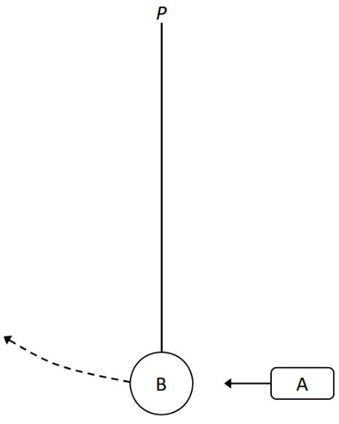
An object A of mass 45 g is travelling at a horizontal speed of 6.2 m s^{–1} when it strikes a resting sphere of mass 80 g.
B hangs vertically at the end of a string, as shown in the diagram.
The string is free to move about point P which is 1.2 m above the centre of B.
During the collision, A and B are in contact for 25 ms.
After the collision, A recoils with a speed of 1.1 m s^{–1}.

- Calculate the force exerted by B on A.
- Calculate the maximum velocity of B.
- Calculate the magnitude and direction of the maximum centripetal force on B.
- Calculate the maximum height gained by B.
- Calculate the maximum angular displacement of the string.
- Draw a labelled diagram to show the force(s) acting on B when it is at its maximum height.
- The string is cut at the instant B is at its maximum height.
What is the magnitude and direction of the acceleration of B after the string is cut?
Question 13 Higher Level 2023
Read the following passage and answer the accompanying questions.
The electric power grid operates based on a delicate balance between supply and demand.
One way to help balance fluctuations in electricity supply and demand is to store electricity during
periods of high production and low demand, then release it back to the electric power grid during
periods of low production and high demand.
Energy can be stored in a variety of ways, including:
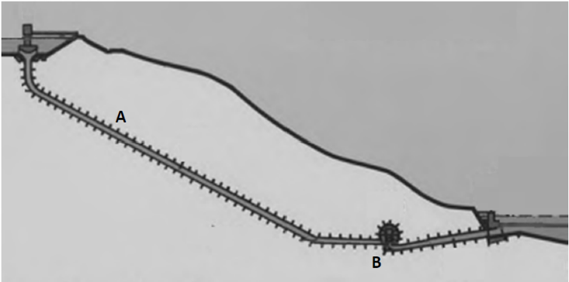
- Pumped storage: e.g. Turlough Hill, a pumped storage power station in Wicklow. It makes use of two water reservoirs, an artificial upper reservoir near the top of a mountain and the naturally occurring corrie lake, Lough Nahanagan, a lower reservoir which is 321 m below.
The upper reservoir has a volume of 2.3 × 10⁶ m³.
The two reservoirs are connected by a pipe of length 584 m. A motor pumps water from the lower reservoir to the upper reservoir, using surplus power available at times of low demand. Water is then allowed to fall by gravity from the upper reservoir back into the lower reservoir, passing through turbines attached to electric generators along the way.

- Flywheels: electricity is used to accelerate a large heavy flywheel which stores rotational kinetic energy.

- Batteries: similar to common rechargeable batteries, very large batteries can store electricity.

Adapted from: epa.gov/energy/electricity‐storage and wikipedia.org/wiki/Turlough_Hill_Power_Station

Assume that the upper reservoir in Turlough Hill is full.
- Calculate
  - the mass (in kg) of water in this reservoir,
  - the potential energy (in J) stored in this reservoir,
  - the maximum power (in W) that could be generated if the reservoir was fully emptied in 24 hours.
- State the main energy conversion that takes place (a) as the water flows down through the pipe at position A and (b) as the water flows through the generator at position B.
- As we move away from generating electricity using non‐renewable sources (e.g. fossil fuels) towards generating electricity using renewable sources (e.g. wind, solar) it is more essential than ever to have energy storage systems such as the ones described in the text. Explain why.
acceleration due to gravity = 9.8 m s^{–2}; density of water = 0.997 g cm^{–3}

Pressure and density: Ordinary level

2023 Question 9 [Ordinary level]
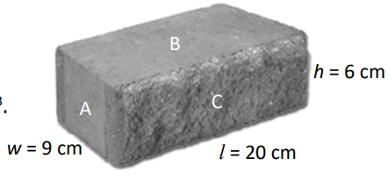
A brick has length l = 20 cm, width w = 9 cm and height h = 6 cm, as shown in the diagram.
The brick has a mass of 2 kg.
- Calculate the volume of the brick in cm³.
- Calculate the density of the brick in g cm^{–3}.
- The bricks are stacked to build a wall. On which side, A, B or C, should a brick be stacked so that it exerts the least amount of pressure on the bricks below it?
- Explain your answer.

Gravity: Ordinary level
2008 Question 6 [Ordinary Level]
The weight of an object is due to the gravitational force acting on it.
Newton investigated the factors which affect this force.
- Define force and give the unit of force.
- State Newton’s law of universal gravitation.
- Calculate the acceleration due to gravity on the moon.
The radius of the moon is 1.7 × 10⁶ m and the mass of the moon is 7 × 10²² kg.
- A lunar buggy designed to travel on the surface of the moon had a mass of 2000 kg when built on the earth.
What is the weight of the buggy on earth?
- What is the mass of the buggy on the moon?
- What is the weight of the buggy on the moon?
- A powerful rocket is required to leave the surface of the earth.
A less powerful rocket is required to leave the surface of the moon.
Explain why.

2014 Question 6 [Ordinary Level]
- Sir Isaac Newton deduced that the weight of an object is due to the force of gravity.
Define force and give the unit of force.
- State Newton’s law of universal gravitation.
- Use the equation below, which is from page 56 of the Formulae and Tables booklet, to calculate, to one decimal place, the acceleration due to gravity on Mars.
The radius of Mars is 3.4 × 10⁶ m and the mass of Mars is 6.4 × 10²³ kg.

- In August 2012 the Curiosity rover landed on Mars.
The wheels of the rover are not as strong as the wheels that would be needed if the rover was to be used on Earth.
Give a reason for this.
- The Curiosity rover was built on Earth to travel on the surface of Mars.
The rover has a mass of 899 kg.
Calculate the weight of Curiosity on Earth
- Calculate the mass of Curiosity on Mars
- Calculate the weight of Curiosity on Mars.
- The Curiosity rover communicates with Earth using radio waves, which are part of the electromagnetic spectrum. Name one other part of the electromagnetic spectrum.
(acceleration due to gravity, g = 9.8 m s⁻²)

2019 Question 6 [Ordinary Level]
Neil Armstrong, the first man to walk on the moon, described seeing the Earth as follows:
All of a sudden, you could see the whole sphere. A great, gigantic, blue ball, covered with a white lace of clouds. It was spectacular.
Armstrong’s love of flying started at a young age. After joining the navy he became a fighter pilot.
- A jet starts from rest and accelerates along a runway to a top speed of 28 m s^{‐1} in 7 seconds.
What is the acceleration of the jet
- Acceleration is a vector quantity, while time is a scalar quantity.
Distinguish between a vector quantity and a scalar quantity.
- The moon is constantly in motion, orbiting the Earth.
Explain why an astronaut standing on the moon has a constant speed but a changing velocity.
- Armstrong had a mass of 90 kg. Calculate his weight on Earth.
Include units in your answer.
- What was Armstrong’s mass on the moon?
- Armstrong’s weight on the moon was only 17% of his weight on Earth. Explain why.
On July 21st 1969, Armstrong became the first man to walk on the moon. An estimated 530 million people watched as he said: That’s one small step for man, one giant leap for mankind. The footprints he made during that walk are still on the moon to this day. The area of Armstrong’s shoe when he took that famous step was 0.03 m². He exerted pressure through his foot onto the surface of the moon.
- Define pressure.
- Calculate the pressure Armstrong exerted on the surface of the moon.
(acceleration due to gravity, g = 9.8 m s^{‐2})

2016 Question 6 [Ordinary Level]
- Define the term force and state the unit of force.
- Force is a vector quantity. Name another example of a vector quantity.
The New Horizons spacecraft visited the minor planet Pluto in 2015.
Newton’s law of universal gravitation is used to calculate the force between two bodies, for example Pluto and the New Horizons spacecraft.
- State the factors which affect the size of the gravitational force between two bodies.
- Pluto has a mass of 1.3 × 10²² kg and a radius of 1186 km. Use the equation below, which is taken from page 56 of the Formulae and Tables booklet, to calculate g, the acceleration due to gravity on the surface of Pluto.

- The mass of the New Horizons spacecraft is 450 kg.
Calculate the weight it would have on the surface of Pluto.
- The closest the spacecraft got to Pluto was 11000 km from the surface of the planet.
Would you expect its weight at this position to be greater or less than it would be at the surface?
Explain your answer.
- The Earth is surrounded by a layer of air, called its atmosphere, which exerts a pressure on the surface of the planet.
Explain why Pluto’s atmosphere exerts a very low pressure on its surface.
- The New Horizons spacecraft used a radioactive isotope to generate electricity, instead of the solar panels used on most spacecraft.
Suggest a reason why solar panels were unsuitable in this case.

2021 Question 14 (a) [Ordinary Level]
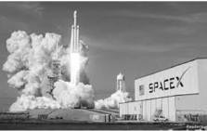
A SpaceX Falcon 9 rocket carrying two astronauts launched from the Kennedy Space Centre in Florida on 30th May 2020. The rocket was headed for the International Space Station (ISS).
- The rocket was visible in Irish skies 15 minutes after take‐off.
At that time it had travelled a distance of 6484 km.
Calculate the rocket’s average speed during this part of the journey.
- The rocket later docked on the ISS. The ISS orbits the Earth every 93 minutes.
How many full orbits of the Earth does the ISS complete each day?
- Newton’s law of universal gravitation describes the force of attraction between the ISS and the Earth.
State Newton’s law of universal gravitation.

The ISS is located 400 km above the Earth’s surface. At this altitude, the acceleration due to gravity is 90% as strong as it is on the Earth’s surface. Before travelling to the ISS, the mass of one of the astronauts was measured to be 85 kg.
- Calculate the astronaut’s weight on Earth.
- What is the astronaut’s mass at the altitude of the ISS?
- Calculate the astronaut’s weight at the altitude of the ISS.
(acceleration due to gravity on Earth’s surface = 9.8 m s⁻²)

Gravity: Higher level

2012 Question 6 [Higher Level]
On 16 August, 1960, Joseph Kittinger established a record for the highest altitude parachute jump. This record remains unbroken. Kittinger jumped from a height of 31 km. He fell for 13 seconds and then his 1.8-metre canopy parachute opened. This stabilised his fall. Only four minutes and 36 seconds more were needed to bring him down to 5 km, where his 8.5-metre parachute opened, allowing him to fall at constant velocity, until he reached the surface of the earth.
(Adapted from http://www.centennialofflight.gov)

- Calculate the acceleration due to gravity at a height of 31 km above the surface of the earth.
- What was the downward force exerted on Kittinger and his equipment at 31 km, taking their total mass to be 180 kg?
- Estimate how far he fell during the first 13 seconds.
What assumptions did you take in this calculation?
- What was his average speed during the next 4 minutes and 36 seconds?
- Assuming that the atmospheric pressure remains constant, how much was the force on a hemispherical parachute of diameter 8.5 m greater than that on a similar parachute of diameter 1.8 m?
- Calculate the upthrust that acted on Kittinger when he reached constant velocity in the last stage of his descent (assume g = 9.81 m s^{–2} during this stage).
(radius of earth =6.36 × 10⁶ m; mass of earth = 5.97 × 10²⁴ kg)

2010 Question 6 [Higher Level]
Radius of the earth = 6.36 × 10⁶ m, acceleration due to gravity at the earth’s surface = 9.81 m s⁻²
Distance from the centre of the earth to the centre of the moon = 3.84 × 10⁸ m
Assume the mass of the earth is 81 times the mass of the moon.
Note that the mass of the earth is not given in this question; this is not a mistake

- State Newton’s law of universal gravitation.
- Use this law to calculate the acceleration due to gravity at a height above the surface of the earth, which is twice the radius of the earth.
Note that 2d above surface is 3d from earth’s centre
- A spacecraft carrying astronauts is on a straight line flight from the earth to the moon and after a while its engines are turned off.
Explain why the spacecraft continues on its journey to the moon, even though the engines are turned off.
- Describe the variation in the weight of the astronauts as they travel to the moon.
- At what height above the earth’s surface will the astronauts experience weightlessness?
- The moon orbits the earth every 27.3 days. What is its velocity, expressed in metres per second?
- Why is there no atmosphere on the moon?

Moment of a force: Ordinary level

2022 Question 14 (c) [Ordinary Level]
The diagram shows a metre stick which is suspended from its mid‐point (50 cm) with three masses hanging from it. The metre stick is in equilibrium.

- A moment is a turning effect caused by a force. The 2 N force and the 4 N force result in clockwise moments about the midpoint of the metre stick. Calculate the total clockwise moment about the midpoint of the metre stick.
- The 7 N force results in an anticlockwise moment about the midpoint of the metre stick.
Calculate the total anticlockwise moment about the midpoint of the metre stick.
- State the law of equilibrium verified by the calculations in (i) and (ii).
- The upward force on the metre stick is 15 N. Calculate the weight of the metre stick.
- Your calculations assume that the centre of gravity of the metre stick acts at the mid‐point of the metre stick.
What might cause this assumption to be invalid?

SOLUTIONS TO ORDINARY LEVEL EXAM QUESTIONS 2002 – 2023

2007 Question 6
- Define work and give the unit of measurement.
Work is the product of force by displacement (distance). Unit: joule
- Define power and give the unit of measurement.
Power is the rate at which work is done. Unit: watt
- What is the difference between potential energy and kinetic energy?
Potential energy is energy a body has due to its position; kinetic energy is energy a body has due to its motion.
- Calculate the total weight raised by the lift’s motor.
7200 + 800 = 8000 N
- Calculate the work done by the lift’s motor.
Work = Force × distance = 8000 × 25 = 200,000 J
- Calculate the power output of the motor.
Power = work/time =200,000/40 = 5000 W
- Calculate the energy gained by the person in taking the lift.
Energy = Force × distance = 800 × 25 = 20,000 J
- Calculate the power generated by the person in climbing the stairs.
Power = work/time = (800 × 25)/120 = 166.6 W
- Give two disadvantages of using a lift.
Needs more energy / uses energy / no exercise so not good for health /cost involved / can be dangerous

2007 Question 12 (a)
- State the principle of conservation of momentum.
The principle of conservation of momentum states that in any collision between two objects, the total momentum before impact equals total momentum after impact provided no external forces act on the system.
- Use the principle of conservation of momentum to explain why a rocket rises.
The gas moves down (with momentum) causing the rocket to move up (in the opposite direction with an equal momentum)
- Calculate the initial momentum of trolley A
mu = 12×3.5 = 42 kg m s⁻¹
- Calculate the common velocity of the trolleys after the collision.
Momentum before = Momentum after
Momentum before = 42, so momentum after = 42
42 = m₃v₃
⇒ v₃ = 42/m₃ ⇒ v = 42/24 = 1.75 m s⁻¹

2008 Question 6
- Define force and give the unit of force.
A force is anything which can cause an object to accelerate.
The unit of force is the newton.
- State Newton’s law of universal gravitation.
Newton’s law of gravitation states that any two point masses in the universe attract each other with a force that is directly proportional to the product of their masses, and inversely proportional to the square of the distance between them.
- Calculate the acceleration due to gravity on the moon.
The radius of the moon is 1.7 × 10⁶ m and the mass of the moon is 7 × 10²² kg.

$g_{m}=\frac{GM}{R^{2}}=\frac{\left(6.6742×{10}^{-11}\right)( 7 × {10}^{22})}{({1.7 × 10}^{6})^{2}}$ = 1.6 m s⁻²

- What is the weight of the buggy on earth?
W = mg = 2000 × 9.8 = 19600 N
- What is the mass of the buggy on the moon?
2000 kg
- What is the weight of the buggy on the moon?
W = mg = 2000 × 1.6 = 3200 N
- A less powerful rocket is required to leave the surface of the moon. Explain why.
Gravity is less on moon so less force is needed to escape.

2009 Question 6
- Define velocity
Velocity is the rate of change of displacement with respect to time.
- Define friction
Friction is a force which resists relative motion between surfaces in contact.
- Calculate how long it took the train to reach its top speed.
v = u + at 50 = 0 + 0.5t t = 50/0.5 = 100 s
- Calculate how far it travelled at its top speed.
s = ut + ½ at² (note that a = 0) s = 50 × (90×60) = 270000 m
- Calculate the acceleration experienced by the train when the brakes were applied.
v² = u² + 2as 0 = 50² + 2a(500) a = −2500/1000 = − 2.5 m s⁻¹
- What was the force acting on the train when the brakes were applied?
F = ma F = 30000× (−)(2.5) = - 75000 N = 75 kN
- Calculate the kinetic energy lost by the train in stopping.
Ek = ½mv² Ek = ½ (30000)(50)² = 37500000 J = 37.5 MJ
- What happened to the kinetic energy lost by the train?
It was converted to other forms of energy such as heat, sound and light (from sparks).
- Name the force A and the force B acting on the train, as shown in the diagram.
A = friction/retardation / resistance to motion
B = weight / force of gravity
- Describe the motion of the train when the force A is equal to the force T.
The train will move at constant speed.
- Sketch a velocity-time graph of the train’s journey.
See diagram

2010 Question 6
- Define momentum
Momentum = (mass)(velocity) // p = mv
- Define kinetic energy
Kinetic energy is energy that an object has due to being in motion.
- State the principle of conservation of momentum.
The principle of conservation of momentum states that in any collision between two objects, the total momentum before impact equals total momentum after impact, provided no external forces act on the system.
- Explain how this principle applies in launching a spacecraft.
The momentum of the rocket is equal but opposite to rocket exhaust
- Calculate the momentum of each skater before the collision
50 × 6 = 300 kg m s⁻¹
70 × 0 = 0 kg m s⁻¹
- What is the momentum of the combined skaters after the collision?
300 kg m s⁻¹
- Calculate the speed of the two skaters after the collision.
300 = (50 + 70)(v)
v = 2.5 m s⁻¹
- Calculate the kinetic energy of each skater before the collision.
Ek = ½mv²
Ek = ½ 50 × 6² = 900 J
Ek = ½ 70 × 0 = 0 J
- Calculate the kinetic energy of the pair of skaters after the collision.
Ek = ½ 120 × (2.5)² = 375 (J)
- Comment on the total kinetic energy values before and after the collision.
Kinetic energy not conserved in collision because some of the energy was given off as heat and sound.

2010 Question 12 (a)
- Calculate the acceleration of the cyclist
F = ma, a = 60/120
a = 0.5 m s^{–2}
- Calculate the maximum velocity of the cyclist after 15 seconds.
v = u + at
v = u + (0.5)(15) = 7.5 m s^{–1}
- Calculate the distance travelled by the cyclist during the first 15 seconds.
s = ut + ½ at² s = ut + ½ (0.5)(15)² = 56.25 m.
- The cyclist stops peddling after 15 seconds and continues to freewheel for a further 80 m before coming to a stop. Why does the bike stop?
Due to friction / air resistance.
- Calculate the time taken for the cyclist to travel the final 80 m?
v² = u² + 2as 0 = (7.5)² + 2a(80) a = - (7.5)²/(2)(80) a = - 0.35

Then use v = u + at 0 = 7.5 – (0.35)(t) t = -7.5/-0.35 = 21.43s

Alternatively we could just have used s = (u +v)t/2
80 = (7.5 + 0)t/2
t = 21.33 s

2011 Question 6
- State Newton’s first law of motion.
A body will remain at rest or moving at a constant velocity unless acted on by an (external) force,
- Draw a diagram of the forces acting on the car before it hit the tree.

- Calculate the acceleration of the car during the collision.
v = u + at $a=\frac{v-u}{t}$ $a=\frac{0-15}{0.4}$ a = 37.5 m s⁻²
- Calculate the net force acting on the car during the collision.
F= ma F =1400 × 37.5 = 52500 N
- Calculate the kinetic energy of the moving car before it struck the tree.
(E = ½ mv² E = ½ (1400)(15)² = 157500 J
- What happened to the kinetic energy of the moving car?
It got converted to heat and sound and also deformed the tree
- Explain, with reference to Newton’s laws of motion, how this could occur.
Even though the car comes to a stop the back-seat passenger will continue to move forward (from Newton’s first law of motion) and so could collide with someone in the front.
- How is this risk of injury minimised?
By wearing a seat belt.

2012 Question 12 (a)
- State the principle of conservation of momentum.
The principle of conservation of momentum states that in any collision between two objects, the total momentum before impact equals total momentum after impact, provided no external forces act on the system.
- Calculate the recoil velocity of the cannon
0 = m₁ v₁ + m₂ v₂ 0 = (1500)( v₁) + (80)(60) v₁ = (-) 3.2 m s⁻¹
- Calculate the kinetic energy of the cannon as it recoils.
(½(1500)(3.2)² = 7680 J
- Why did the cannon recoil?
For momentum to be conserved (because initially there was no momentum and the cannonball went forward).
- Why will the cannon come to a stop in a shorter distance that the cannonball?
Because the cannon has a bigger mass / the resistance of the ground (friction) is bigger than that of air / the cannon had a smaller recoil velocity

2014 Question 6
- Define force and give the unit of force.
Force is something which can cause an acceleration. Unit is the newton
- State Newton’s law of universal gravitation.
states that any two point masses in the universe attract each other with a force that is directly proportional to the product of their masses, and inversely proportional to the square of the distance between them.
- Calculate, to one decimal place, the acceleration due to gravity on Mars.
= $g=\frac{GM}{d^{2}}= \frac{\left(6.67×{10}^{-11}\right)(6.4×{10}^{23})}{{(3.4×10}^{6}){}^{2}}=3.7 m{ s}^{-2}$

- Give a reason for this.
the rover weighs less on Mars // gravity is less on Mars // the mass of Mars is smaller than mass of Earth
- Calculate the weight of Curiosity on Earth
W = mg = (899)(9.8) = 8.8 × 10³ N
- Calculate the mass of Curiosity on Mars
899 (kg) // the same as on Earth
- Calculate the weight of Curiosity on Mars.
W = mg = (899)(3.7) = 3.3 × 10³ N
- Name one other part of the electromagnetic spectrum.
microwaves, infra-red, visible light, ultra-violet, X-rays, gamma rays

2015 Question 6
- Define potential energy
Potential energy is the energy an object has due to its position in a force field.
- Define kinetic energy
Kinetic energy is energy an object has due to its motion.
- State the principle of conservation of energy.
states that energy cannot be created or destroyed but can only be converted from one form to another.
- Explain how the principle applies to a roller-coaster.
Potential energy at top of roller-coaster is converted into kinetic energy as speed increases / height decreases
- Calculate the difference in height between point A and point B. 75 m
- Calculate the change in the potential energy of the car between A and B.
Change in potential energy = potential energy at A – potential energy at B
= mgh₁ – mgh₂
= (850)(9.8)(100) – (850)(9.8)(25)
= 624750 J
- Write down the kinetic energy of the car at point B, assuming there is no friction and no air resistance.
Due to conservation of energy, the potential energy lost between A and B must equal the kinetic energy gained.
The car lost 624750 J of potential energy so gained the same amount of kinetic energy, and given that it had no kinetic energy to begin with, its potential energy at B must also be 624750 J.
- Calculate its velocity at point B.
½ mv² = 624750 J ½ (850)v² = 624750 J v² = 1470 v = 38.3 m s⁻¹
- Calculate the deceleration of the car between B and C.
v² = u² +2as
0 = (38.3)² + 2a(95)
(38.3)² = - 190a
a = -7.7 m s⁻²
- Calculate the average force required to bring the car to a stop.
F = ma F = (80)(7.7) F = 6576 N

2016 Question 6
- Define the term force and state the unit of force.
Force is anything that can cause an object to accelerate
- Name another example of a vector quantity.
Displacement, velocity, acceleration, etc.
- State the factors which affect the size of the gravitational force between two bodies.
Mass of first body
Mass of second body
Distance
- Calculate g, the acceleration due to gravity on the surface of Pluto.
$g= \frac{GM}{d^{2}}=\frac{(6.67 ×{10}^{-11)})(1.3×{10}^{22})}{{(1.186×{10}^{6})}^{2}}= \frac{8.67×{10}^{11}}{1.4×{10}^{12}}$ = 0.62 m s⁻²

- Calculate the weight it would have on the surface of Pluto.
Weight = mg = 450 × 0.62 = 279 N
- Would you expect its weight at this position to be greater or less than it would be at the surface?
Explain your answer.
Less because it’s further away (from Pluto)
- Explain why Pluto’s atmosphere exerts a very low pressure on its surface.
The gravitational force of attraction is much smaller, Pluto has a small mass (relative to the earth), etc.
- Suggest a reason why solar panels were unsuitable in this case.
Pluto is too far from the sun so they wouldn’t generate enough energy

2016 Question 12 (a)
- Define kinetic energy and potential energy.
Kinetic energy is energy an object has due to its motion.
Potential energy is the energy an object has due to its position in a force field.
- Calculate the potential energy of the egg before it was dropped.
Potential energy = mgh = (0.052) (9.8) (2) = 1.02 Joules
- Calculate the velocity of the egg as it hit the ground.
The potential energy of the egg at the top = the kinetic energy of the egg at the bottom
mgh = ½mv²
⇒ v² = 2gh
⇒ v² = (2)(9.8)(2) = 39.2
⇒ v = 6.26 m s⁻¹
- Suggest how the egg could be protected from breaking when it hits the ground.
Place a soft material (e.g. balls of paper) on the ground under it to give it a soft landing, etc.
- State one everyday application of the principal behind the protection of the egg.
Air bags in cars, on the ground for safety when workers are up on a height, etc.

2017 Question 6
- Explain the underlined terms.
Force: causes an object to accelerate
acceleration: rate of change of velocity
gravity: force of attraction between masses
- What form of energy does the pod have due to its motion?
kinetic (energy)
- What form of energy does the pod have at its highest point?
potential (energy)
- Why do the occupants experience apparent weightlessness at the pod’s highest point?
freefall / no reaction force / no support force
- Calculate the potential energy stored in the springs before the pod is released.
PE = mgh = 400 × 9.8 × 50 = 196 000 J
- Draw a diagram to show the forces acting on the pod when it is released.
diagram to show: downward force/ weight, upward force / tension
- Calculate the momentum of the pod when it has a speed of 8 m s^{‒1}.
p = mv = 400 × 8 = 3200 kg m s⁻¹
- State one energy loss that might prevent the pod from reaching its maximum height.
friction / air resistance

2018 Question 6
- Define momentum. momentum = mass multiplied by velocity
- Define kinetic energy. Energy = ½mv²
Use the principle of conservation of momentum to explain why the cannon recoils.
Momentum before collision = momentum after collision /to conserve momentum
- Calculate the momentum of each car before the collision.
Momentum of A= m_{A}v_{A}= (500)(6) = 3000 kg m s^{‐1}
Momentum of B= m_{B}v_{B}= (300)(0) = 0 kg m s^{‐1}
- What is the momentum of the combined cars after the collision?
total momentum before = total momentum after
Total momentum before = 3000 kg m s^{‐1}
So total momentum after = 3000 kg m s^{‐1}
- Calculate the speed of the two cars after the collision.
3000 + 0 = (m_{A} + m_{B})V₃
= (500+300) V₃
V₃ = 3.75 m s^{‐1}
- Calculate the kinetic energy of each car before the collision.
½mv² = ½(500)(6)² = 9000 J
½mv² = ½(300)(0)² = 0 J
- Calculate the kinetic energy of the cars after the collision.
½mv² = ½(500+300)(3.75)² = 5625 J
- What conclusion can be drawn from the change in kinetic energy that happens during the collision?
kinetic energy is not conserved / is lost

2019 Question 6
- What is the acceleration of the jet?
v= u + at ⟹ 28 = 0 + a(7) i.e. a = 4 m s^{‐2}
- Distinguish between a vector quantity and a scalar quantity.
vector quantities have a direction (scalar quantities don’t)
- Explain why an astronaut standing on the moon has a constant speed but a changing velocity.
when the moon orbits it changes its direction of motion so its velocity changes
- Armstrong had a mass of 90 kg. Calculate his weight on Earth.
weight = m g = (90)(9.8) = 882 N
- What was Armstrong’s mass on the moon?
90 kg
- Armstrong’s weight on the moon was only 17% of his weight on Earth. Explain why.
smaller mass of moon // less gravitational force // value for g is less
- Define pressure.
pressure is the force per unit area
- Calculate the pressure Armstrong exerted on the surface of the moon.
$P=\frac{(882)(0.17)}{0.03}$ = 4998 Pa

2022 Question 14 (a)
- What is meant by kinetic energy?
energy due to motion
- State the principle of conservation of energy.
energy cannot be created or destroyed but only converted from one form to another
- What is the main type of energy that the stone’s kinetic energy is being converted into as it travels upwards?
potential energy
- Calculate the kinetic energy of the stone when it is thrown.
E = ½mv² E = ½ × 0.005 × 15² = 0.5625 J
- Calculate the maximum height reached by the stone.
E = mgh
h = E/mg
0.5625 ÷ (0.005 × 9.8) = 11.5 m
- What is the unit of energy?
Joule / J

2022 Question 14 (c)
- Calculate the total clockwise moment about the midpoint of the metre stick.
(2 × 0.1) + (4 × 0.3) = 1.4 N m
- Calculate the total anticlockwise moment about the midpoint of the metre stick.
7 × 0.2 = 1.4 N m
- State the law of equilibrium verified by the calculations in (i) and (ii).
clockwise moments = anti-clockwise moments
- The upward force on the metre stick is 15 N. Calculate the weight of the metre stick.
15 – (7 + 2 + 4) = 2 N
- What might cause this assumption to be invalid?
e.g. chipped metre stick etc.

I know. I don’t get out much.
Work = force × displacement The force and displacement must be in the same direction; if they are not in the same direction then multiplying force by displacement is no longer an option. We’re snookered. But what’s that in the distance? Is it a bird? Is it a plane? No, it’s vector analysis! We can calculate the component of the force which is in the same direction as the displacement and multiply this component by the displacement. Whew. Thank you vector analysis. The bad news however is that you have to wait until Mechanics III to figure out how to do this.
Anytime work is done energy is transferred This is a very important concept but is often overlooked. We will come across it again when dealing with an electron getting accelerated between two points (by which time you will have forgotten all about this). Converting sound energy to heat energy Heating a cup of coffee by shouting at it can actually work – it will just take 8 years 7 months and 6 days. Unless you’re an experienced P.E. teacher – in which case one good long shriek usually does the trick.
E = ½ mv² This means that the energy associated with a car has is proportional to the square of the velocity. If the speed increases by a factor of two (say from 20 mph to 40 mph), the energy increases by a factor of four. If your speed increases by a factor of three (say from 20 mph to 60 mph), the energy increases by a factor of nine. This is important because stopping distance is proportional to kinetic energy (can you say what part of the notes that comes from?) so if you go from 20 mph to 60 mph your stopping distance gets nine times longer. Who knew that physics was related to the real world?
Newton’s cradle When two balls go in, two go out at (almost) the same speed: momentum is conserved, although kinetic energy is not. So why, if two go in, can't one go out at twice the velocity? Turns out momentum would be conserved, but kinetic energy wouldn't. Try working it out by letting the mass of each sphere be 1 kg, and the initial velocity be 1 m s⁻¹. James Joule is credited with being the first person to realise that energy is conserved. When a German Physician named Robert Mayer read a paper by Joule on energy conversion he claimed that he discovered it first, but that the journal he sent it to refused to publish it because it was ‘a crackpot idea’. Joule disputed his priority and Mayer flings himself out the third-floor window of his house and is later committed to an asylum where he ended up in a straitjacket. Granted that’s a bit extreme, but it would be nice to see some of you get just a little animated about any aspect of physics from time to time. The principle of conservation of energy is one of the most important concepts in all of Science. It should come with flashing neon lights. Let’s also not forget that there was one important exception to this. Before the Big Bang there was no energy. After the Big Bang there was quite a lot of energy – in fact there was all the energy that we have now. So I think it’s true to say that energy was certainly created at least once. And that’s just this universe. And absolutely nobody knows why this happened. I very much doubt that we ever will and so many of our so-called explanations sound little more than quasi-religious made up stories (the principle of conservation basically says that all there is is all there is). I guess some things are just outside the scope of our puny minds - physics is so much easier when you don’t think about it.
All of the energy in the universe right now could only have come from the Big Bang 15 billion years ago – imagine that! Every sound you hear, every movement you make, all that energy originally came from something that was never there to begin with. Is that not simply mind-blowing? You couldn’t make it up. If you don’t agree then maybe it’s not too late to give up Physics and switch to Accounting. Now while this energy can’t disappear (you can’t actually waste energy), it can change form. This is what an energy conversion is and these energy conversions are going on all around us all the time. The problem with energy conversions is that the useful energy going out is less than the energy taken in (power stations). The technical term is that the energy is ‘less ordered’, or ‘more chaotic’.
Some industries still use ‘horsepower’ as the unit of power. Ironically the term was introduced by James Watt because he wanted to show mine-owners how much better his steam engines were compared to the traditional way of pumping water from flooded mines (using horses). So for he needed to have a ‘unit’ to use for comparison purposes. See video links in thephysicsteacher.ie.
The human brain runs on 20 watts of electricity (chemical energy from food to electrical energy – enough to power a dim light bulb).That’s roughly 20% of the body’s energy consumption, despite representing only 2% of its weight.
How does your power (kept up for a few seconds) compare with that of a horse over a working day (550 W)?
Why do we have this concept? One kilowatt-hour is equivalent to 3600000 joules so the numbers on your electricity bill would simply be too big if they were left in joules. This concept appears again in our Electricity II booklet, this time with a lot more associated exam questions.
Its value for the planet as a whole is approximately 1360 W m⁻² but this can change from one place to another. Can you think why? In Ireland the solar constant is 120 W m⁻² which is less than 10% of the global average - what implications does that have for our health?
Why mass divided by volume? Let’s say that we have 2000 kg of water and it takes up a volume of 2 m³ and we want to establish the density of water. If we divide 2000 by 2 it means that we have just calculated what the mass of 1 m³ of water would be – without ever needing to find the mass of 1 m³ of water on its own. And that’s why the density of water is 1000 kg/m³. We can repeat for other volumes of water and in each case we will get the same density. We could do the same for any material. So when you think about it, dividing the total mass by the total volume is equivalent to finding the mass of 1 m³ (or the mass per unit volume). Cool trick innit?
Pressure is a scalar quantity It is incorrect (although not unusual) to say "the pressure is directed in such or such a direction". The pressure, as a scalar, has no direction. The confusion is often due to the fact that force can have a direction associated with it, and therefore is a vector. Pressure however does not have a direction associated with it.
But what is the cause of this upthrust? Well we know that the water is exerting pressure on the rubber duckie and also that the pressure increases the farther down you go (ΔP = ρgΔh). Upthrust is a result of the pressure difference between the bottom and the top of an object submerged in a liquid. That’s my official answer but I have a niggling feeling that I don’t fully understand it myself. But then as a colleague of mine always used to say: “If I don’t know it, you don’t need to know it!”
I have my reservations about both Archimedes’ Principle and the Law of flotation being on the syllabus. They are valuable concepts in their own right but don’t reappear anywhere else and so are isolated nuggets rather than concepts that blend into the overall picture of physics.
The law of flotation: To make sense of this it might help to see where it comes from. Consider the forces acting on a rubber ducky in the bathtub: Floating object is not accelerating; implies upward force = downward force Upthrust = weight of floating object But from Archimedes Principle; Upthrust = weight of displaced fluid weight of displaced fluid = weight of floating object
What are the biggest obstacles to digging a really, really deep hole? Answer: temperature and pressure: The temperature increases by about 1 degree Celsius per 100 meters of depth while pressure increases significantly as well. This can make drilling difficult and dangerous. The Soviet Union gave it a go (starting in 1970) but managed only 12 km or so and even this took them 20 years. When I say ‘only’ bear in mind that the United States planned to drill down 5 km but gave up after just 183 so in that context 12 km is quite impressive (they were aiming for 15 km). Temperatures at that depth were 180 degrees Celsius which was a lot more than they had bargained for and drill bits coming in contact with rock (which was remarkably soft) keep melting. But why is it so hot down there? Because of nuclear reactions which have been going on since the planet first came into existence 4.5 billion years ago. And yes, we will be looking at the nuclear reactions in more detail next year. So how close did the Soviet Union actually get to the centre of the Earth? They made it 0.002% of the way. By the way, if you were to drill deep into the Earth it would only be dark for the first 60 kilometres. Below that, it's so hot that the Earth itself starts glowing in visible light.
“therefore the apple draws the earth, as well as the earth draws the apple” So when you ‘drop’ your keys and the planet pulls them down towards the ground, which experiences the bigger force of attraction; your keys or the planet? Answer: The force of attraction is the same for both. Can you say why? So why doesn’t the planet accelerate up towards the keys?
I desire you do not ascribe innate gravity to me … that one body may act upon another at a distance is to me so great an absurdity, that I believe no man who has in philosophical matters a competent faculty of thinking, can ever fall into it. Isaac Newton. In a separate letter to a friend he writes: You sometimes speak of gravity as essential as inherent to matter. Pray do not ascribe this notion to me, for the cause of gravity is what I do not pretend to know and therefore would take more time to consider it. What made Newton so uncomfortable about this ‘action at a distance’ explanation for the gravity is that he had no way to explain it and in fact it seemed that there are occult forces at play, yet this was at a time when Science was trying to separate itself from exactly this type of explanation. As a result Newton went to great lengths to point out that his treatment of motion would be a mathematical treatment only: The words “attraction”, “impulse” or any “propensity” towards a centre, however, I employ indifferently and interchangeably, considering these forces not physical but merely mathematical. The reader should hence beware lest he think by words of this sort I anywhere define a species or mode of action, or a physical cause of reason. ... If one asks why one thing draws another - It is answered by "a certain drawingness it hath"'. As for Lord Kelvin, well he flatly stated - "Present science has no right to attempt to explain gravitation. We know nothing about it. We simply know NOTHING about it". We tend to think that Newton somehow ‘invented’ gravity. Obviously gravity always existed and as far back as 628 CE Indian astronomer Brahmagupta spoke of gravity as an attractive force. But Newton’s gravitational law did have two things going for it; he was able to show how to calculate the size of the gravitational force and – as we will see later – he was able to prove mathematically that it is correct. It also proved conclusively that both the planets in the heavens and everyday objects here on Earth all followed the same rules. I’m not sure that it’s possible to appreciate the significance of this from our vantage point today. After Newton died scientists went to a lot of trouble to promote him as the person to whom all other scientists should aspire. So they downplayed his interest in both astrology and alchemy. They would also have been uncomfortable with the role which he believed God played in maintaining the motion of the heavens. Sometimes they went a little overboard. One Victorian biographer noted that in addition to his intellectual contribution, Newton’s life was ‘one continual source of labour, patience, charity, generosity, piety, goodness and all other virtues, without a mixture of any vice whatsoever’. So just like Donald Trump. However we should never forget Newton’s greatest achievement here which was to conclusively demonstrate that the motion of the heavens did actually follow the same laws of physics which applied here on Earth. It was this which later Einstein was referring to when he noted that ‘the most incomprehensible fact about the world is that it is comprehensible’.
Why does ‘big G’ have this value? Nobody knows but if it was even a little bit different then galaxies and even planets would never exist – so nobody would be around to notice it. It’s a little scary when you think about it. Google ‘weak and strong anthropic principles’ to learn more.
I suppose for the sake of consistency I could do the same. But then I wouldn’t be me.
A nice tip to help students distinguish between mass and weight is to always include the name of the planet when talking about weight. So we would say "weight on Mars" and "weight on Earth" rather than just "weight." Whereas mass is always the same wherever you are. Mass is mass is mass. One way to think about gravitational force (‘weight’) is to compare it to magnetism. If you bring a north pole of one magnet up to the south pole of another magnet there is a ‘pull’ between the two. If you move one magnet away from the other then while the mass of each magnet remains the same, the force of attraction decreases, similar to the way your weight will decrease if you move away from the surface of the Earth. Of course for mass you really should be distinguishing between gravitational mass and inertial mass. See two pages further on for more.
Perpendicular distance. Draw a line through the force vector; this is known as the ‘line of action’. The perpendicular distance corresponds to the distance between the fulcrum and this line of action. We will look at examples of this when we cover the mandatory experiment on this topic.
vector sum of the forces means “add up all the forces, but if forces are in opposite directions then make one direction positive and the other direction negative”. We could look at the forces in any direction but here we just consider forces up and down.
I probably shouldn’t assume that you know what the terms ‘clockwise’ and ‘anti-clockwise’ mean; if you don’t then your best option is to look it up on YouTube.

